RSSBC: Tremendous performances in the Chester Long Distance Sculls
Tuesday 1 October 2013
Brandt Beckerman (O LVI)
On Sunday three RSSBC rowers participated in the Chester Long Distance Sculls event on the River Dee. Crews from across the region came to compete over 5,000 metres in sculling boats ranging from novice singles to elite quads.
New entrants Brandt Beckerman (O LVI) and Lettie Tay (MSH LVI) had a tremendous start to their RSSBC rowing careers, with a 1st place finish in the IM3.1x for Brandt and a 2nd place finish in the IM1.1x for Lettie. Returning oarsman George Patterson (R VI) also raced well, finishing 11th in the Nov.1x category.
The crews will be aiming to continue their success next week as the Club travels to Runcorn to compete in the Runcorn Autumn Head.

Hockey: an encouraging start to the new season
Tuesday 1 October 2013
With several key hockey players among the summer 2013 leavers and only four players from last year's team remaining, it was difficult to know at the beginning of term how a new team would gel together and what sort of standard it would be. However, after the first couple of training sessions with the new squad, it was clear we had nothing to be anxious about.
At the beginning of this term, we felt our hockey was heading slightly into the unknown. With only four players from last year’s team remaining, it was difficult to know how a new team would gel together and what sort of standard it would be. After the first couple of training sessions, however, it was clear we had nothing to be anxious about. The Lower Sixth girls coming into the squad are motivated and eager to learn, which has made team training go very well.
Our first game was against The King’s School Chester on Wednesday 18th September. They are usually a strong side and their team is mostly unchanged from last year. Shrewsbury started fantastically well, being particularly strong in attack, and it wasn’t long before we were rewarded with a short corner. Satisfyingly, exactly as in training, the ball came out and was struck cleanly by Antonia Schüler into the bottom right corner. 1-0 Shrewsbury.
King’s came back strong and continued to push forward for the remainder of the half, equalising just before half time. In the second half, Shrewsbury continued to work hard, but it was obvious that King’s were determined to push on for the win. After ten minutes, Alice Sykes-Waller made a great run into the D and scored. 2-1 Shrewsbury. After this, Shrewsbury struggled to get it out of their half, as King’s continued to attack well. With fifteen minutes to go, King’s equalised for a second time to make it 2-2. Shrewsbury tried to regain possession, but King’s were too strong and took advantage of some poor defensive play by Shrewsbury. Three goals in ten minutes gave King’s a 5-2 victory. Although the result was disappointing, it was a pleasing start for the new Shrewsbury team with lots to build on in the following weeks.
Last week, on Wednesday 25th September, Shrewsbury hosted Wrekin College. This is always a competitive fixture against a strong side, and this game was no exception. The hockey was a good standard from the off and both teams played well, particularly in the midfield, making it end-to-end play and a lot of running around. Attack for both teams was stronger than defence, but neither could be penetrated in the first half so it remained 0-0 at half time.
Shrewsbury went close to a goal early in the second half with a good move up the right wing, but were denied by some good goalkeeping. Wrekin then made a break and were awarded a short corner which they converted: 1-0 Wrekin. And this is how the game finished. Shrewsbury played some exceptional hockey at times, but were just not able to convert their chances.
We continue this week preparing for Wrekin Invitation 7s Tournament on Wednesday 2nd October.

Netball news
Tuesday 1 October 2013
The netball team is delighted to report that they have had an unbeaten run in their league matches to date...
This year, Shrewsbury has entered a team into the Shrewsbury and District Netball Association winter league (SDNA). The league consists of 45 teams playing in four divisions across three different venues. Division 4 is hosted at Shrewsbury School and is a great way of warming the teams up for the Lent term netball fixtures. Fixtures take place on a Monday night in the gym and Shrewsbury have made an excellent start.
On Monday 9th September Shrewsbury played Newtown B. They had just come down from division 3, so were going to be a tough first game. The Shrewsbury team was entirely made up of Lower Sixth, so were a little slow to get going, having never played as a team together before. At half time they were down by 2. In the second half, we seemed to find our rhythm and played much better as a cohesive team, resulting in a 19-14 win. A great result for our first game in this adult league.
The following week’s game was against Eclipse. Shrewsbury started much stronger than the previous week and were up by 6 goals at half time. The end result was a 22-8 win.
The next fixture was against Vixens, who had also played 2 and won 2 so was due to be a tougher match. Shrewsbury started fantastically well, converting every centre and pushing hard defensively to turn over their centres. The final result was a much deserved 23-11 win.
The most recent game for Shrewsbury was Monday 30th September against Sugar and Spice and we tried out a few different players and positions. This variety of team play demonstrates our depth in netball this year and the team produced a great performance, winning 22-7.
NJB

Friends of Shrewsbury School (Hong Kong) Dinner to be held on 21st October 2013 in Hong Kong
Wednesday 2 October 2013
Over the last few years, current and past Shrewsbury families and Old Salopians living in Hong Kong have come together in conjunction with Robin Case, who retired as Registrar last summer, to form The Friends of Shrewsbury School (Hong Kong) Association. At a formal dinner last November, attended by 113 people, the Headmaster and the Chairman of the Association, Willie Cheng, signed the Articles of Association, setting out the aims and objectives and providing for a new structure and membership in the years ahead. Many families attending the dinner signed up and became formal members.
During their annual trip to Hong Kong to interview potential pupils and visit local schools last week, Director of Music John Moore, Admissions Manager Verity Llewelyn-Jones and Robin Case were pleased to host a dinner on behalf of the School for the Friends of Shrewsbury School (Hong Kong) Association Committee at the Snow Garden Restaurant.
The guests were: Chairman Willie Cheng (father of Michael (I UVI) and Jonathan (I LVI)), Vice Chairman Joseph and Michelle Law (parents of Derek (O UVI), May Tsui (mother of Adrian Yick (2013 leaver) and Bryan (M LVI)), Sarah Lo (mother of Clive Lam (O UVI) and Ivan (M LVI)), Dennis Lo (father of Douglas (2012 leaver) and Daniel (SH LVI), Carson and Denise Lee (father of Marco (I V)), Lawrence and Adeline Cheung (parents of Calvin (O V)), Helen Mayhew (mother of William (2013 leaver) and Henry (Ch 3rd Form)) and K.H.To (father of Eugene (2012 leaver).
The Friends' Annual Dinner will take place on Monday 21st October at the Bankers' Club, Hong Kong, hosted by the Headmaster Mark Turner and Chairman Willie Cheng; arrivals from 6.30pm, to sit down at 7.30pm. All members of the Salopian family in Hong Kong are warmly invited to attend. For further details, or to find out more about the Association, please contact Mr Willie Cheng (wilcheng@netvigator.com).

Salopians attend London Mathematical Society lectures
Wednesday 2 October 2013
Miscarriages of justice, the Goldbach conjecture and other unsolved problems of number theory... The London Mathematical Society lectures in Birmingham gave some fascinating food for thought for the aspiring mathematicians in the audience.
A group of 13 pupils, accompanied by Mr Armstrong and Dr Oakley, travelled to Birmingham on Thursday 26th September to attend two lectures put on by the London Mathematical Society.
The first lecture was by Ray Hill from the University of Salford and was an eye-opening, and often macabre, talk on miscarriages of justice and misuse of mathematics and logic in trials. He revealed a series of fallacies with a range of case studies from the famous OJ Simpson trial to a tragic case of cot deaths. The talk certainly highlighted the importance of a rigorous mathematical education.
The second talk was by Vicky Neale, a member of Murray Edwards College, Cambridge, on 'Addictive Number Theory'. She went through a series of problems in number theory, building up from the primes in their infinite number and working up to the unsolved problems of number theory. There were a few formulae designed to scare the audience but it was a well pitched talk that introduced applications of modular arithmetic in a simple way. The talk also highlighted that a conjecture that is easily formulated and seemingly irrefutable can take years for somebody to prove; for example the Goldbach conjecture that states that every even number can be expressed as a sum of two primes, still remains without proof. All even numbers up to 4 quintillion have been checked, so you will have to look further than that for a counterexample.
The two talks gave excellent food for thought for the audience of aspiring (and confirmed) mathematicians.
CWO

An invitation to all members of the Salopian community in celebration of National Poetry Day
Thursday 3 October 2013
from Kristina Leslie, Head of English

Dear All,
As I'm sure you know - today is National Poetry Day. All of the Third Form will be writing poetry in their English lessons this morning which will form a Third Form Competition. The rest of the School has also been invited to submit poems to me - before midnight tonight - from which some winners will also be selected.

Having also extended this invitation to members of staff, I thought there was no reason why parents should miss out! Therefore, if you have the creative urge, and would like to send me a poem sometime before the clock strikes midnight tonight (Thursday 3rd October), turning me into a pumpkin, I would be thrilled to receive them! I already have several entries from pupils - but no pressure! Any theme or style you like...

Yours,
Kristina Leslie

A week in the life of Rob Homden (Rb UVI)
Thursday 3 October 2013
As a member of both the 1st VIII rowing crew and the School Orchestra, Rob Homden has a packed timetable at the best of times. With the additional responsibility of organising Radbrooke's unison and part songs for the hotly contested House Singing Competition - now only three weeks away - Rob is especially busy this first half of term.

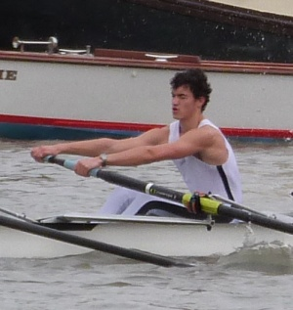
Monday 23rd September
Up until 4 o'clock, my day was filled up with double Biology, a Chemistry test, double Physics and double Maths, planning the week’s part song rehearsals and printing off 60 copies of the lyrics for the House unison. This was followed by two hours of rowing and some volunteer running coaching for DofE. It’s now 8 o’clock and I can’t feel my legs as I sit down to start some Top Schools, but hey – I don’t need them for writing! By 9pm it’s time for the newly founded Philosophy Society (philsoc. 9-10pm Quod – just saying…) Home. Food. Sleep. Recharge…

Tuesday 24th September
A double ‘PR’ during period 4 and 5 comes as a welcome opportunity to get ahead in advance of a busy week and to buy the sweets to make House Singing run smoothly… Another two hours of rowing and then the first part song rehearsal of the week. (I can’t tell you more – spies are among us!) I get home early at 8:45pm, and plan my next few days.

Wednesday 25th September
Just five lessons – Physics, more Physics, Chemistry, Maths, more Maths. A short day academically, but three hours of rowing more than makes up for it! After stumbling back to House exhausted, I take the hour before dinner to finish small tasks and recover slightly, a few minutes of down time listening to music and relaxing in my study, then back to work. The day is rounded off with School Orchestra from 7:00 to 8:45. (concerts coming up – again I’m just saying…) before heading home to compose a little on my keyboard while in a musical mood, and then off to sleep.

Thursday 26th September
Chemistry test period one, results back by the second half of the double, followed by Physics and double Biology. Then, an afternoon’s work and a 2000m ergo at rate 22, and 20 minutes steady state rowing, before quickly returning to House for a part song rehearsal (… still not saying). Next up – the Sports Science as a Career lecture until 7:15pm. Finally I return home before 8:00pm for the first time all week.

Friday 27th September
Coach weekend beckons. An early finish to the week, to get ahead and to catch up with friends from out of School, but not until I’d completed a 6:15am rowing session and lessons. From the second I stepped into the boat, I knew the week was catching up with me, and by 8am, it had caught me up completely. Then, when hope seemed lost by break-time, I was revitalised by toast and Nutella before surging on to lunch time. A shortened week – thank goodness!

Giles Bell’s ‘Team of the Week’
Thursday 3 October 2013
In a departure from his usual weekly focus on one of the School's football squads, Giles Bell's 'Team of the Week' this week is the Chapel Choir.
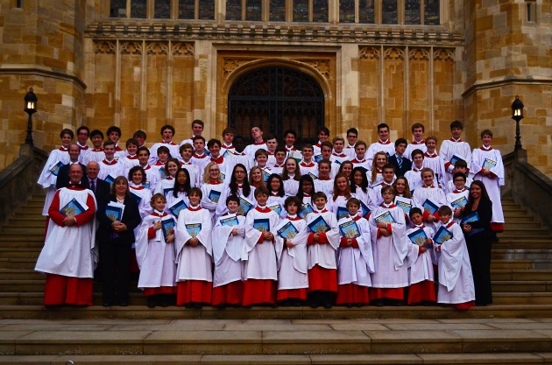
On Wednesday morning at 11.30am, two buses left the School packed to the rafters with the Chapel Choir and their junior Trebles contingent from Shrewsbury High Prep School, their cassocks, surpluses and a serious amount of KH picnic fodder. Their destination: St George’s Chapel, Windsor to sing evensong.
All went smoothly and the stop at Oxford services was hardly worth mentioning, although W H Smiths had a good deal on bars of chocolate and they did a brisk trade. The mood of the team was very cheerful and voices seemed to be in good order as they returned to the bus for the last leg of the journey. We arrived at about 3:15pm in the Windsor bus park. It was good to see a number of buses already parked up, some from overseas, no doubt having efficiently and speedily emptied their passengers in anticipation of gaining a front row seat in the Chapel. The choristers and their ‘minders’ rapidly raced off through the Windsor shopping arcade, barely noticing the Golden Arches or the large lolly shop, such was their concentration on the job in hand. Gathering in front of the entrance to the Castle, the seventy-strong throng of songsters managed to avoid a confrontation with the heavily armed policemen and were allowed in to practice. Such was my confidence in the team, I went off to meet with the Director of Studies at St George’s Choir School, followed by a leisurely amble round the town taking in ice-cream and tea shops. I had to add in a quick visit to Woods of Windsor when I realised I had my wife’s car keys in my pocket and that she had just realised that too!
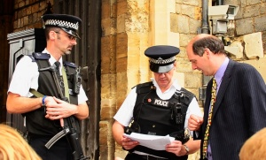
I had the good fortune to bump into some of the Choir’s many fans on the way to the Chapel. A healthy queue for evensong was forming and a sense of anticipation hung in the air. (I spent an anxious few minutes with the police (see right) but they did eventually allow me in - when it was clear I was with the Fowlers.) The last time I had ventured into the Castle was to see one of my friends singing in the choir after his stag night- his solo was staggering! You will be glad to know that our team were in top condition, although Laurence Jeffcoate admitted to me that he was feeling unwell. Such was his determination not to let the side down, he was prepared to go through the pain barrier for his manager. “I am prepared to go through the pain barrier for my manager,” Laurence told me. Despite Laurence’s commitment, I was slightly concerned that as one of the Choir’s Galacticos (Laurence has recently been informed by Queen’s College, Oxford that he is being considered for a Choral Scholarship), his illness might affect the balance of the Choir. Yet as the Choir walked purposefully into the Chapel, I relaxed when I realised that in the same way Real Madrid have Bale and Ronaldo, Shrewsbury School Chapel Choir has a plethora of singing stars.
The service began and so did three quarters of an hour of sheer delight. The setting, the sights, the sound – it was simply magnificat! Our Chaplain had not made the trip as he was doing his ‘rounds of the parish,’ but his ‘stand in’ at the Chapel had a voice that helped us forget the absence of the Holy Father. The Choir were quickly into their set pieces. The Canticles by Noble, a beautifully sung psalm and the anthem ‘Thou will keep him in perfect peace’ by Wesley were all delivered crisply and with a precision Wayne Rooney would have been proud of. John Godwin’s delight in playing a ‘fantastic organ’ was evident. His Duruflé had never sounded so good and it was clear that JG was close to heaven. “It was like flying a jumbo jet. You just had to touch the keys and the sound - woh!” Fellow organ enthusiast Dan Lo told me he felt privileged to see a Harrison and Harrison and a Royal Peculiar in the same day!
After the service there was praise and glorification for the Choir from all sides. A couple of music fans from Atlanta Georgia said that they had been blown away by the sound and that we must be very proud of our Choir. Philipp Legner (OS) had come back to see his sister Henrike and had thoroughly enjoyed the experience. Manager Alex Mason was ecstatic. “It was a great experience and an example of great teamwork. What an Ensemble! Standing on Jane Seymour’s grave gave me an Historical Head rush!” One or two other Choir members had also noted who they were standing on! Henry VIII, Charles 1st and Queen Anne’s infant son, to name but a few! “It was well wicked,” remarked Connie Osborne. John Moore was delighted and declared it the “best ever”. The St George’s Windsor Choirmaster James Vivian was heard to exclaim, “What a sound!”
It was then back on the buses after a quick word with the adoring fans. Another smooth trip home, some watching Toy Story 3 and a brief stop for a visit to Burger King – well they deserved it! Actually they probably deserved better!
All in all, what a trip and what a team. Hats off to the Choir!

GJFB

School Sailing Trip: Gosport, September 2013
Thursday 3 October 2013
As part of the RYA Yachtmaster tuition (shore-based) on Thursday afternoons, a short expedition was organised over Coach Weekend to obtain some practical experience. It is described here by Ed Chamberlain (Ch V).

Other pupils taking part were Hugo Morgan, Brendan Parsons, Dan Lo, Toby Thomas, Hector Kaye and Tiger Vechamamontien.
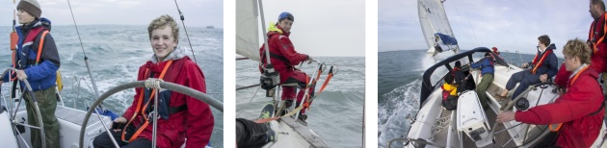
Above left: Hector Kaye and Brendan Parsons at the helm; centre: the author, Ed Chamberlain; right: heeling round the Isle of Wight
It was the first time I had ever been yacht sailing, despite doing years of dinghy sailing, and it was nowhere near what I anticipated! What I had been expecting was for people to sit around whilst one person helms the boat, and for it to be rather boring. How wrong I was. There was always something to do: lookouts to avoid the huge ships, yachts and mooring buoys, sail handling, navigating, preparing food, and everything else associated with watchkeeping. All that, at the same time as huge fifteen foot swell* pushing the boat from side to side and force seven* gusts sweeping across the boat. It was one of the most awesome times I have ever had.
The night sailing on day 1 was a maze of different flashing lights and pitch black water. The following day we went sailing around the Isle of Wight, starting at Gosport, past Bembridge and round the south, clockwise. It was an experience I will never forget. The early start, despite beginning with the lightest wind of the day, still managed to wake the whole crew up within an hour of sailing. But then, within three hours of setting off, merely going below deck was an achievement in itself – the waves caused the boat to toss suddenly from side to side, throwing you all across the cabins. But then, as we hit the west side of the island we had far calmer and more peaceful seas, and we eventually rounded the Needles and anchored in Alum Bay for lunch. Tacking up the West Solent was a lot of fun, getting spray-soaked on the foredeck. Something about a big boat heeling is very different to a dinghy heeling over.
Then, overnight at Cowes and back to Gosport the next day finished a tiring but thoroughly enjoyable trip. Thanks to Mr Kaye and Mr Tim Osborne for helping, and Mr Lapage for organising/skippering it.
*Skipper’s comment: may have been a bit less than that!

Excellent performances by Salopian fencers in the Shropshire Open
Thursday 3 October 2013
The Shropshire Open was held at Wrekin College last weekend and attracted over 160 fencers, including a number of European competitors. Seven pupils from the School entered and all performed very well. Marco Lee (I V) was on particularly impressive form, coming second in the Men’s Foil.
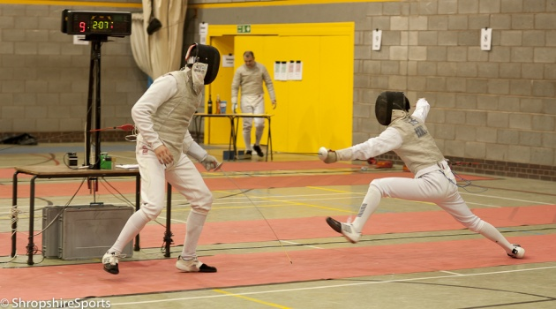
Marco Lee lunging at his opponent in the final of the Men's Foil.
Photo courtesy of Shropshire Sports http://shropshiresports.com
This was the first experience of an open competition for three of the Salopian fencers and all did extremely well. Lucy Petch (MSH UVI) a finished 13th in a very strong field in the Ladies' Sabre competition; Izzy Codron (EDH UVI) finished 10th in the Ladies' Foil; and Tom Creamer (S LVI) finished 45th in the Men’s Epée.
Ross Viljoen (PH LVI) and Jonty Small (M UVI) competed in the Men's Sabre event, finishing 17th and 25th respectively.
Marco Lee (I V) was in top form throughout the day, winning through to the final of the Men’s Foil event. Although he eventually lost to David Alexander (Nottingham) 15-6, this was a tremendous performance.
Scott Reynolds (Rb V) also competed very well in the Men’s Foil and finished 29th.
Ken Holding
Fencing Coach

Chapel Choir sing evensong at St. George's Chapel, Windsor (home page)
Friday 4 October 2013
On Wednesday 2nd October, the Shrewsbury School Chapel Choir were priviliged to sing evensong at St. George's Chapel. Richard Hudson, Housemaster and English master, recounts his experience below of this memorable occasion.
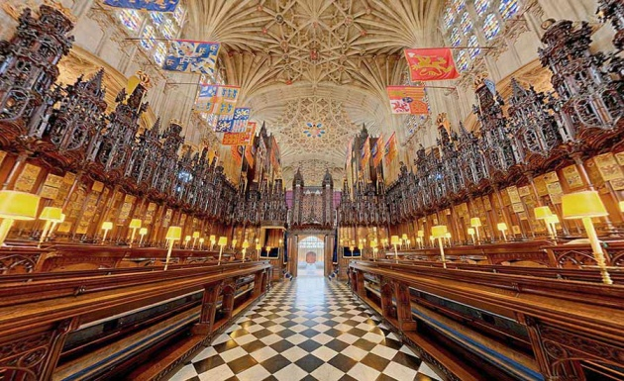
For many of the 70 strong Chapel Choir, I suspect the prospect of the three-hour coach journey to Windsor was less than enticing, and given the choice, a routine morning of lessons might possibly have seemed more attractive. As the crenellations of Windsor Castle came into view, however, anticipation and excitement took over, and barely three hours later, when all was done and the Choir was assembled on the West End steps for a photo, the universally shared sense of a very special occasion just experienced was palpable.
The Dungeon provided the most surreal of surroundings for the brief rehearsal, in which more seemed to go wrong than right, holes in the cold stone walls showing where shackles had once been anchored, the groans of prisoners replaced 500 years later by the soaring voices of choristers.
Sadly the length of the journey and the need to rehearse left little or no time for sightseeing, and there was barely enough time for the briefest of visions of Eton Chapel, bathed in late afternoon sunlight, looking almost grotesquely huge, perhaps even tauntingly, at the denizens of its Salopian country cousin.
And then into the Chapel, first to see if we could all squeeze in to the magnificent Garter stalls, and just as importantly, still retain a view of Director of Music Alex Mason, the ghostly eyes of generations of monarchs looking I hope indulgently on us. The acoustic was incredible, so limpid that each singer had that disconcerting sensation that he was singing alone. For this type of music – the Reading responses, a lengthy chanted psalm, the Noble ‘Magnificat’ and ‘Nunc Dimittis’ and the Wesley anthem – absolute precision and perfection of intonation is a prerequisite. Few choirs are privileged to sing in the Chapel Royal and the highest standards are rightly expected. And they were given par excellence. In the spirit of all Salopian performances, adrenaline, and the unseen influence of the architectural and historical ambience galvanised the choir which sang magnificently, organist Dr John Godwin providing as ever the most solid of foundations.
Unconscious symbolism was provided by director Alex Mason standing on the tomb slab of Henry VIII and Jane Seymour, the parents of our founder Edward VI, as he conducted. Henry, a considerable musician himself - when not acquiring or disposing of wives - would surely have approved of the sounds he was hearing.
And so for the long journey back, with the consciousness of a Salopian ‘first’, in every sense, behind us.
RTH

Golf: IGSA knockout competition
Saturday 5 October 2013
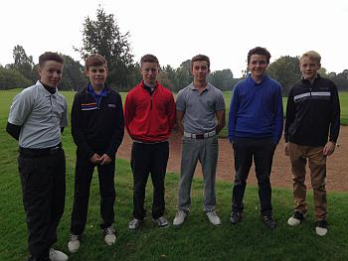
Shrewsbury came up against a strong Kings Macclesfield B team at Shifnal golf club, in the ISGA knockout competition on Wednesday 2nd October. It was a good match up of skills on paper in this singles matchplay, played off scratch. Ben Oswald, off 6, took on their 5 handicapper and won 3 and 1 with some good golf played throughout; James Walker, off 6, had some driving worries before the game but took on their 7 handicapper and lost 3 and 1; Jonty Robinson, off 9, played well but the big hitting Kings Mac captain proved a handful off 9 handicap.
Once again, this was great experience for the young side and we now go into the plate competition where we could do better as it will be played off handicaps.

RSSBC: Runcorn Autumn Head, 5th October 2013
Monday 7 October 2013
The Boat Club took eighteen crews from across all of the age groups to compete at the Runcorn Autumn Head on Saturday 5th October. It was a very promising first run out for the Club, with eight crews coming away with medals.
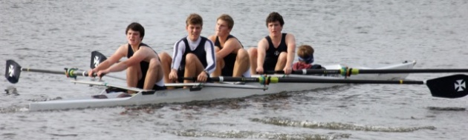
The winning J18 coxed four
The Boat Club took eighteen crews from across all of the age groups to compete at the Runcorn Autumn Head. It was a very promising first run out for the Club, with eight crews coming away with medals.
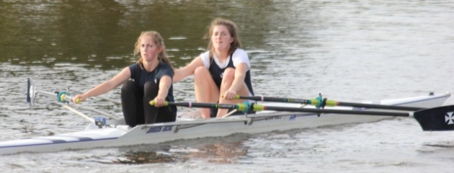
The winning women's IM3 double
Wins were recorded in the Elite Coxed Fours, J18 Coxed Fours, IM3 Doubles, Women’s J18 Quads, Women’s IM3 Doubles, Novice Quads, J16 Coxed Fours and J15 Coxed Fours.
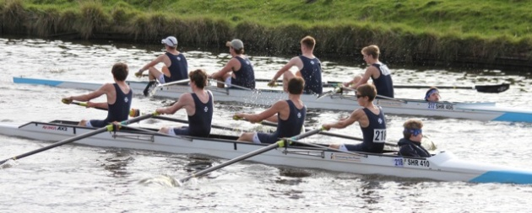
The winning J16 coxed four (this side)
While the J14s were the only age group not to record a win, for many of them it was their first ever race, having started rowing last month. The top crew had to settle for an excellent second place out of five crews. A complete list of results can be found at http://runcornrowing.com/
Attention now turns to a whole Club fixture against The King’s School Chester on Saturday, with the J16 and Senior crews racing away at Chester and the J14 and J15 crews competing at home.
Below: the winning J15 coxed four; bottom: the J14s rowing in their first race
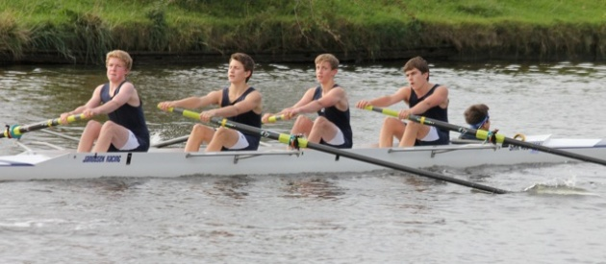
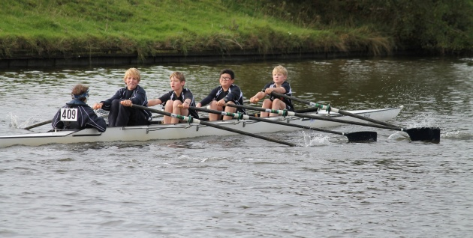

Chapel Choir trip to St George's Chapel, Windsor - 3rd October 2013
Monday 7 October 2013
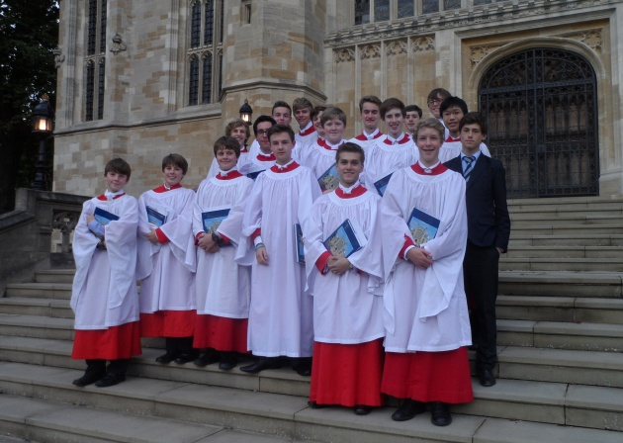
Churchill's members of the Chapel Choir on the steps of St George's Chapel, Windsor

RSSH: The revival of an annual Hunt fixture and the start of something new
Wednesday 9 October 2013
These are historic days for the Hunt. The day before reviving a fixture against Rugby School that dates back to the 1990s, Huntsman Rory Fraser created a new Hunt 'first' by running a sub-8-minute Benjy in a kilt. (To find out why, please see below.) This Sunday, the Hunt will challenge for the Marathon World Record, raising funds for projects in Africa that they will visit during their tour during the Half-Term Exeat.
On Saturday 19th October, 15 members of the Hunt will set off for East Africa, having been invited by 'Coach' Sentayehu Eshetu (who last year spent a precious few days in Shrewsbury as the Hunt's inaugural 'Coach in Residence') to visit him in Bekoji, Ethiopia and train with his athletes, who have in the past included over a dozen Olympic champions.
The Hunt have been busy raising much needed funds for two projects that they will visit during their trip. This Sunday, they will be raising funds for Running Across Borders, which supports running programmes for young people in Ethiopia. Fifteen members of the Hunt will be heading down to the track at London Road to attempt as a group to break the Marathon World Record of 2.03.23, set by Kenya's Wilson Kipsang in the Berlin Marathon at the end of September. If anyone wishes to donate money, they can contact pjm@shrewsbury.org.uk.
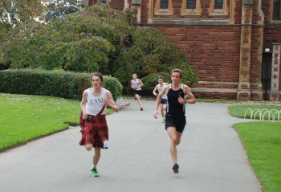
In a mad-cap venture of his own on Monday, Huntsman and Head of School Rory Fraser set himself the challenge of running a Benjy (1.5 miles) in under eight minutes wearing a kilt. He did it in 7.49 - and raised over £180 for the Sanata Restart Centre, which cares for and educates orphans and streetchildren from the town of Gilgil, Kenya. As a group, the Hunt have so far raised £850, which will pay for a child in Kenya to come off the streets and be housed, fed and educated at the Restart Centre for a year.
"I decided to run a Benjy in a kilt for two reasons: 1) I get really embarrassed asking people for money so I jolly well have to make it worth their while; 2) my family has quite strong African connections through my grandfather 'Rory Fraser' who died in his early 30s, so I thought he would have approved of my wearing the family tartan for a cause he would have undoubtedly supported! (The founder of the Restart Centre is also Scottish!)
The charity itself is completely fantastic. After hearing a talk about it, I was utterly inspired. I cannot stress enough how special I think it is. To use public school understatement, it is no mean feat running in a kilt, roughly the same drag as a bolshie five-year-old around your waist. But a large proportion of the donation relied on my getting under 8 minutes, so considering the severity of the situation, I ran like a nutcase..."
Meanwhile on Tuesday 8th October, the Hunt welcomed Rugby School to Shrewsbury for a friendly cross-country fixture over the Tucks course, reviving what had been an annual fixture. The fixture dates back to the 1900s, but somewhere along the line had died out. It was therefore a particularly special day of racing as the two great schools met again.
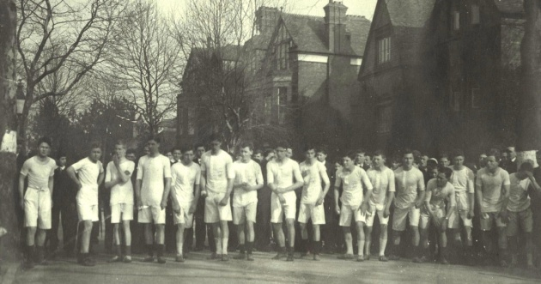
Above: Lining up at The Schools for the RSSH v Rugby School race, 1918
Below: The start of the RSSH v Rugby School race, 2013
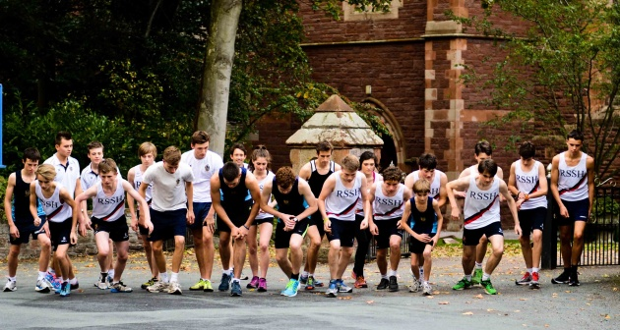
An early surge from Rugby School's captain Ben Sutherland saw him take charge of the race just behind our hare, Mr Haworth. Ben is looking to challenge for a National Schools' medal this year on the track, so we knew he would be in good form. Nevertheless, a strong chasing pack ensured that the Hunt were in the thick of things behind him. Ben Remnant looked to be extremely strong heading up the long uphill section of Pulley Lane, and indeed was bitterly disappointed to have to pull out later due to a strained muscle. This left his rival Oscar Dickins in charge of the chasing pack and it looked for some time like he might be able to take the scalp of the Huntsman Rory Fraser. However, Rory timed his race perfectly and produced a sprint to cross the line as the first Hunt runner in a time that equalled last year's winning Tucks time. Sutherland's time of 17.29 was impressive and only 9 seconds off our School record over the course, held by George Mallett (Huntsman 2011-12). Just out of the medals was Fourth Former Charlie Tait-Harris, with a time of 18.28 that suggests he could be a threat in next week's Tucks race. First girl home was Tory Mobley in a time of 20.56 that suggests she can perhaps challenge for an unprecedented top 30 place in the whole-school Tucks race.
Whilst Rugby took the individual win, the Hunt showed their strength in depth with 2nd-7th all Shrewsbury runners. A team score of 20 to 48 was a comfortable victory, though Rugby School are certainly on the ascendancy, so watch the results of this (now hopefully annual again) fixture with interest!
PJM

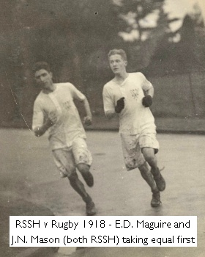
RSSH vs Rugby School, Tuesday 8th October 2013
POSITION | NAME | SCHOOL | TIME
1 | Ben Sutherland | Rugby | 17.29
2 | Rory Fraser | RSSH | 18.08
3 | Oscar Dickins | RSSH | 18.11
4 | Charlie Tait-Harris | RSSH | 18.28
5 | Ralph Wade | RSSH | 18.32
6 | Will Hayward | RSSH | 18.37
7 | Charlie Godman | RSSH | 18.45
8 | Simon Waterhouse | Rugby | 19.05
9 | Sean Sawyer | RSSH | 19.59
10 | Charlie Bruce | Rugby | 20.12
11 | Charlie Davis | RSSH | 20.46
12 | Tory Mobley | RSSH | 20.56
13 | Jake Samuel | RSSH | 20.57
14 | Harry Sutherland | Rugby | 22.01
15 | Alex Winter | Rugby | 22.02
16 | Lucie Cornwell-Lee | RSSH | 22.22
17 | Thompson | Rugby | 22.31
18 | Hunt | Rugby | 22.31
19 | Matt Jackson | Rugby | 22.43
Five runners to 'count'. Italics indicates non-scoring runner.
RESULTS: RSSH - 20 points RUGBY - 48 points
Below: RSSH v Rugby School, October 2013
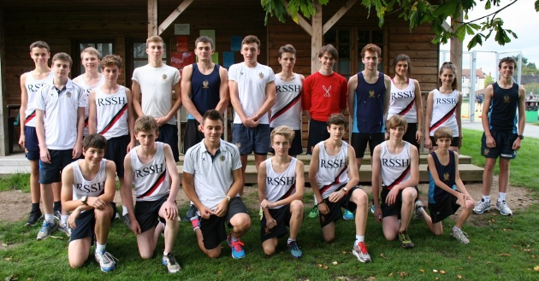

High expectations: 1st XV rugby coaching sessions with former England scrum-half Shaun Perry
Wednesday 9 October 2013
The players and current staff are delighted to welcome former England scrum-half Shaun Perry to the School's rugby coaching staff. Shaun brings a wealth of experience gained through premiership and international rugby and has already created a rapport that will inspire Shrewsbury School's players to new heights of performance – as is evident in this account by Rob Treasure (I UVI).
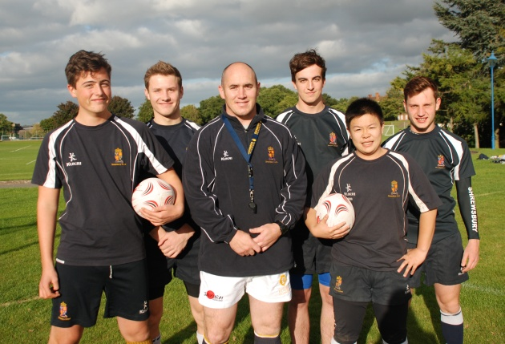
L to r: Rory Free, Ivan Sanin, Shaun Perry, Sam Roberts, Tommy Tang and Koster Manser
During the six weeks that Shaun has been coaching the 1st XV, he has become part of Shrewsbury School rugby, bringing with him a good sense of humour combined with extensive experience of both playing and coaching the sport. His is undoubtedly a ruthless coach and has worked the squad harder than any 1st XV team has ever been worked before. Using his knowledge of the game from a player's perspective, Shaun has worked with backs and forwards and has certainly improved every player's individual skill set. As well as this, he brings with him a passion for the sport and an enthusiasm for us to improve and enjoy rugby as much as he does. He loves to get involved himself, whether it is beating Roan (our scrum-half) at the 'cross bar challenge' from the halfway line, or just joining in with training.
Despite his relentless sessions, there is never a moment when Shaun isn't laughing. He has bonded well with the squad and shares our pride in the School and our determination to win. Over the course of this term and the next, Shaun will continue to work with us and help us to develop as a team and to play the best rugby that we possibly can.
Rob Treasure (I UVI)

Sixth Form Charity Fashion Show raises over £2,000
Thursday 10 October 2013
More than 300 guests packed in to the Alington Hall on Saturday for an evening of glitz and glamour at the Annual Sixth Form Charity Fashion Show.
Organised by a dedicated group of Sixth Formers led by Hattie Warner and Poppy Beckett, the event was a triumphant success and a tribute to all the hard work that had gone on behind the scenes. From contacting the boutiques to organising publicity, selling tickets, preparing the models and planning the show itself, the girls had been busy for months.
Hattie and Poppy were both relieved and delighted with the results: “The evening went well and it seemed that the guests enjoyed themselves. Overall everything ran smoothly with no major disasters or trips on the catwalk. The girls each had about nine outfits, so there wasn't much time to change. The boys also had some very quick changes, so the assistance from the helpers backstage was fantastic.
“We would like to say a massive thank you to everyone who helped us – Suzanne Younger for compering the evening, the models, the helpers on the night, Alex Davies and Will Allott for all their technical wizadry, the shops for lending the clothes, Francis Peel and Whitebridge Wines, Awen Blandford and George Bates for their wonderful music during the interval, the Save the Children ambassadors, KH staff, Mrs Drew, Mrs Wordie and our parents.”
The clothes that were modelled came from Hayley J, House of Fraser, Templeton Jones, Pockets, Street Vintage, E.A. Jones Vintage and Maggie Mae’s.
The evening raised over £2,000 for Save the Children.

The Tucks: Friday 18th October 2013
Thursday 10 October 2013
As we build up to next week's annual Tucks race, we can look forward to a Salopian tradition that continues to be an important part of the annual School year. Parents and friends are warmly invited to come and support – though please be aware that is no parking in Meole village this year, so cars will either have to be parked at the School or nearby.
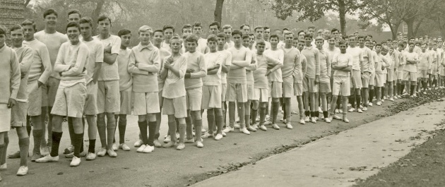
Lining up for the Tucks, 1926
First run in the early 1830s, the Tucks can lay claim to being one of the oldest-established races in the world, and is perhaps unique in involving every single member of the School. The race was originally intended as a diversion to prevent boys from attending race meets on the old Racecourse Lane site (now the Shrewsbury Hospital). The Tucks was named after the farmer whose fields they ran across. His very generous wife would supply the runners with home-brewed ale and cider, though alas, this tradition has not survived!
In 2008, for the first time in the race's history, girls competed in the annual event, and in 2011 Captain of Girls’ Running Imola Atkins broke into the top 100. This year, there is a strong possibility of one of our new Sixth Form girl entrants breaking into the top 50, so watch this space! In recent years, there have been some extremely swift times at the top end, with Huntsman George Mallett running 17.20 in 2011, one of the fastest times ever in the history of the race. In the team event, Severn Hill have dominated in recent years, though with a number of their key runners having now left the School, there is perhaps an opportunity for two or three new houses to contend for the coveted team championship.
Parents are warmly invited to come and support the run, though do please note that there is no parking in Meole Brace village itself this year. Parents and supporters can either park at The Schools and walk down with the pupils for the 2pm start, or park nearby. It should prove to be an enjoyable afternoon of racing, and the lungs will be nicely opened up for the House Signing that evening!
PJM
Below: Lining up for the Tucks last year
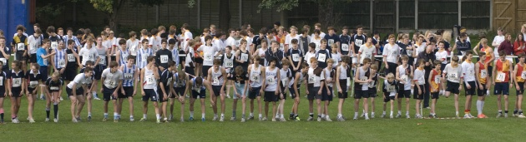

A week in the life of Joe Bell (Rb LVI)
Thursday 10 October 2013
During the last week, Joe Bell has given no fewer than four public performances - two as part of the School's Chapel Choir and Orchestra, and two solo gigs.

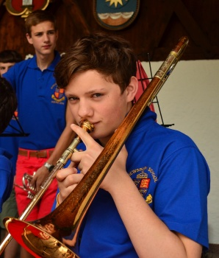
Monday 30th September
After just coming back from a coach weekend and probably feeling more tired than I had a right to be, I was greeted with a whole school assembly in the early hours of the morning. I then had a day filled with English, History, R.S. and Theatre Studies, and my trombone lesson at the end, followed by a night of essays. Yum. Monday is one of my more relaxed days, not having sport or music in the evening.

Tuesday 1st October
Tuesday was another relaxed day, the first Tuesday I haven’t had a rehearsal for the senior school play, Antigone. The performances of the play are in November, and I am playing the sentry, a comical part. Antigone is a famous Greek Tragedy by Sophocles, and the Director of Drama, Brian Parsons, is doing a modern interpretation of it. Drama scholar Jessica Walker is playing Antigone, and Hugo Scott is playing Creon, the main male lead. The set will be amazing as well. Don’t want to give anything away... come and find out!

Wednesday 2nd October
Lessons for Wednesday were cut short by a Choir trip to St George’s Chapel Windsor. We left at ten past eleven to experience the joys of a three-hour coach journey, with a KH packed lunch to keep us all going – not the ideal meal, but edible. We arrived at Windsor to face armed guards at the gate, and going to rehearse in a chapel within the Castle. Unfortunately, there were no royals around (Aw) but we sang a forty-five minute evensong at five, and there were a lot of people to see it. In the words of Giles Bell, it was a ‘magnificat’ service, and it was a privilege to sing in Windsor, as not many people get the chance to. One of the advantages of having relations at the school is that Dad came on the trip and bought me a burger king on the way back, so it was a healthy supper for me. We got back around ten, and I stayed up late doing another essay, contemplating why it hadn’t occurred to me that it wasn’t an amazing idea to do all essay subjects for A level, but ah well. Learn from my mistakes.

Thursday 3rd October
I slept-walked into school on Thursday morning, and had a morning Chapel service with Reverend Dobbie, followed by an R.S. essay in class for Mr Tonks. I found out on Thursday that I had a concert at St Alkmund’s on Sunday, so my weekend wouldn’t be all that relaxing. I had an Orchestra rehearsal Thursday night. I play trombone, a really cool instrument by the way, especially for awesome people. I spent most of the afternoon practising for an open mic night the next night.

Friday 4th October
Friday was an average day of lessons, but in the evening I had an open mic night at The Hive in town. I played three songs – a jay-z/Robbie Williams mash up, a song by Newton Faulkner, and a song that I wrote, singing and playing guitar. It went well, and I was asked to play at another place in town next Friday, but I have a philosophy lecture (sigh). After this I shamefully enjoyed a trip to McDonalds, my second burger of the week. Note that this is not how I normally live; this is a bad week for my health. The open mic night was for a charity event, ‘Oxjam,’ raising money for Oxfam.

Saturday 5th October
Saturday we had an eight thirty start in the morning, due to the Bradfield football fixtures. In my opinion, sport should be illegal. It gets in the way of everything, and I’m not very good at it. I held my eyes open and managed to take in at least some of my Saturday lessons’ information. After lunch, I went to my Dad’s friends’ wedding, a Buddhist wedding. Well, really just an ordinary wedding between two Buddhists, but a Buddhist wedding sounds more exotic and exciting. It was a good afternoon and evening, and I played a song there, a mash-up of Bruno Mars and the Beatles. (I know, my mash-ups are abnormal.)

Sunday 6th October
On Sunday evening I played in the St Alkmund’s concert with the Orchestra, which went very well. I only played in a small part, but there were various brass groups and Awen Blandford played a very good solo on cello. The standard of music was high, and the turnout was good as well. After the concert, I ran into bed to mentally prepare myself for the next week.

Chapel Choir sing Evensong in St George’s Chapel, Windsor
Thursday 10 October 2013
"Few choirs are privileged to sing in the Chapel Royal and the highest standards are rightly expected." Richard Hudson paints a vivid picture of the Chapel Choir's memorable and historic visit to St George's Chapel, Windsor last Wednesday.
For many of the 70 strong Chapel Choir, I suspect the prospect of the three-hour coach journey to Windsor was less than enticing, and given the choice, a routine morning of lessons might possibly have seemed more attractive. As the crenellations of Windsor Castle came into view, however, anticipation and excitement took over, and barely three hours later, when all was done and the Choir was assembled on the West End steps for a photo, the universally shared sense of a very special occasion just experienced was palpable.
The Dungeon provided the most surreal of surroundings for the brief rehearsal, in which more seemed to go wrong than right, holes in the cold stone walls showing where shackles had once been anchored, the groans of prisoners replaced 500 years later by the soaring voices of choristers.
Sadly the length of the journey and the need to rehearse left little or no time for sightseeing, and there was barely enough time for the briefest of visions of Eton Chapel, bathed in late afternoon sunlight, looking almost grotesquely huge, perhaps even tauntingly, at the denizens of its Salopian country cousin.
And then into the Chapel, first to see if we could all squeeze in to the magnificent Garter stalls, and just as importantly, still retain a view of Director of Music Alex Mason, the ghostly eyes of generations of monarchs looking I hope indulgently on us. The acoustic was incredible, so limpid that each singer had that disconcerting sensation that he was singing alone. For this type of music – the Reading responses, a lengthy chanted psalm, the Noble ‘Magnificat’ and ‘Nunc Dimittis’ and the Wesley anthem – absolute precision and perfection of intonation is a prerequisite. Few choirs are privileged to sing in the Chapel Royal and the highest standards are rightly expected. And they were given par excellence. In the spirit of all Salopian performances, adrenaline, and the unseen influence of the architectural and historical ambience galvanised the choir which sang magnificently, organist Dr John Godwin providing as ever the most solid of foundations.
Unconscious symbolism was provided by director Alex Mason standing on the tomb slab of Henry VIII and Jane Seymour, the parents of our founder Edward VI, as he conducted. Henry, a considerable musician himself - when not acquiring or disposing of wives - would surely have approved of the sounds he was hearing.
And so for the long journey back, with the consciousness of a Salopian ‘first’, in every sense, behind us.
RTH

Girls' hockey: 1st - 7th October
Wednesday 10 October 2012
Although the 1st XI were beaten by a well drilled Wrekin College side on Wednesday, Shrewsbury were able to field our first ever 2nd XI which managed to defeat their Wrekin counterparts 4-3!
On Saturday, the 1st XI defeated Bedstone College 5-1. Scorers were Charlie Perkins, Libby Naylor, Hannah Pritchard, Elen Murphy, Lizzie Mason-Jones.
After adjusting to the unfamiliar grass pitch conditions, Shrewsbury played very fluent, attacking hockey. Half time saw the 1st XI 4-0 up, through four different scorers, including excellent finishes from Lizzie Mason-Jones (MSH) and Captain Libby Naylor (EDH). In the second half, Man of the Match Tilly Whittingham (MSH) put in a brilliant defensive performance with Eliza Wood (EDH), to keep Bedstone at bay. Further determined attacking work, saw Shrewsbury extend the lead, and finish with an excellent win.

Giles Bell’s ‘Team of the Week’
Thursday 10 October 2013
This week the (almost) undefeated U16As...
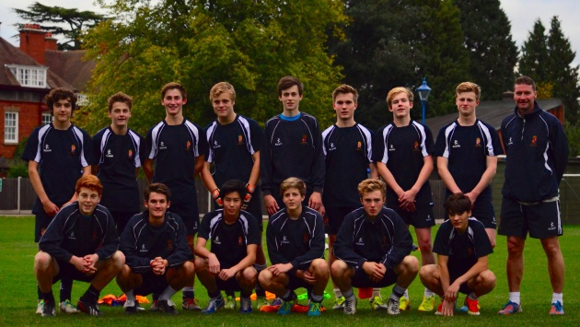
The U16A squad with manager Andy Cook
I like to think I make the right choices in my life most of the time. I like my wife, I like my house, I like my van, I like my football club; in fact I like most things that I have had an input in. Obviously you can’t have an input in everything, but I have even been lucky with the deal I have been handed. My parents did not beat me too much, the sets I am teaching at present are full of studious and charming young people, my cat does not scratch me more than once a month, and although my dog went blind it does mean he does not need quite so many lengthy walks. All was going well until I chose the under-16As as the team of the week.
They had won all their games so far this season, apart from a 1-0 defeat to Idsall at the start of term (and I am reliably informed that if the ref had taken the crowd’s advice and gone to Specsavers, he would have seen Billy Riggall’s acrobatic bicycle kick that hit the bar had bounced down over the line. More pressure on the Bursar to invest in goal line technology!) A 2-1 win away at Bradfield, courtesy of a Mason penalty and a Schofield screamer that was hit with pace, precision, power, clinical finesse, ruthless yet controlled aggression and was actually meant as a cross, was the last shred of evidence I needed that they were the Team of the Week. Goalkeeper Sam Mitchell told me that the match teas at Bradfield tasted all the sweeter after that result. “The match teas at Bradfield tasted all the sweeter after that result,” he said. Surely a win in their cup game against local rivals Thomas Telford would be a formality and we could all bask in their reflected glory.
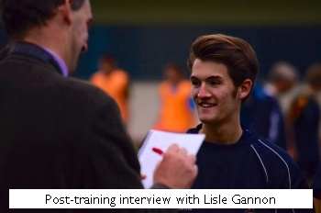Sadly, I have to say that despite the awesome training session I witnessed yesterday, the gods were against the lads today and they went down narrowly (4-0); so that they can concentrate on the League. There was also collateral damage. I was refereeing the 5th XI match v Ruthin 1st XI on the next door pitch and found my eyes wandering across to see how the Under-16s were faring. This caused me to miss all five of Ruthin’s goals which, my team told me politely after the game, were all offside. If only I had been concentrating we would have won 2-0. (I also missed two clear penalties for us!)
It would not be right to concentrate solely on the cup upset, for this Under-16 A team are a good side and will no doubt bounce back. Even Manchester City have the odd bad day and Brighton suffer from a multitude of bad days – but I still like them! There would be no clichés after the game. Billy Wriggall told me he was “sick as a parrot” and Eliot Sobol felt it was “a game of two halves”. Manager Andy Cook told me that he would have been “over the moon” if the lads had won but that he does not like heights, and so in away he was quietly quite pleased with the result. He gave credit to a very good Thomas Telford team: “With a name like that you think they are going to be a bit of a one man team, but they weren’t.”
Andy is a very experienced campaigner, having played for Burnley, Stoke, Bradford City and of course Shrewsbury Town. He has drilled a good footballing acumen into his side and the spirit is clearly a good one. Training is taken seriously and despite my attempts to take numerous photographs they were a focused bunch – unlike my photos. (Thankfully the ever-reliable Andrew Spicer was also on hand to capture the session for posterity.)
The squad consists of Sam Mitchell in goal and a defence built around man mountains such as Tom Hart, Tom Breese, skipper Jake Morris, Gene Ratanadaros, Ed Stubbs and senior pro Giles Holroyd, who played for the under-16As last year and is the only player on a long-term contract. The midfield maestros include the wily Elliot Sobol, Lisle Gannon, Ben Jones, Toby Mason, Billy Riggall, and the target men and goal-scoring machines are Harry Schofield and Ed Dolphin. With Max Parsonage on loan to the 1st XI along with old man Anton Nelson, there is plenty of talent in this gang and I am looking forward to watching them follow the Cook’s orders and serving up some more treats for before the season is done. They have some interesting games coming up in the shape of Charlton and Whitworth HS (I am assuming that is the High School and not the High Security institution – otherwise we might never get the ball back!).
Good luck to the Cookie Monsters for the rest of the season!
GJFB
Below: The U16A squad in training - l to r: goalie Sam Mitchell; Gene Ratanadaros; Giles Holroyd and captain Jake Morris; Tom Breese
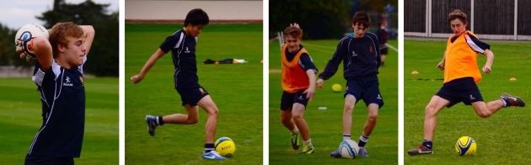

The Legendary Churchill's Link...
Monday 14 October 2013
Head of House Ben Lyster-Binns greets his troops.
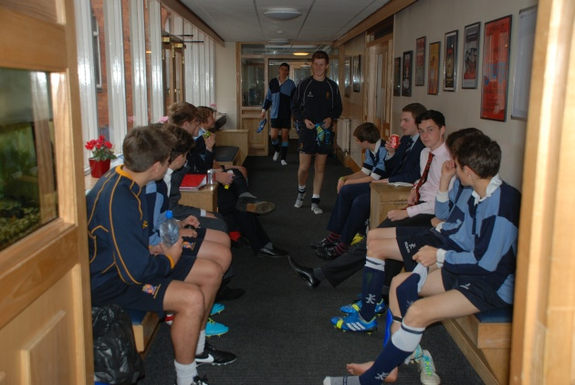

Churchill's Third Form visit to 'Tally'
Monday 14 October 2013
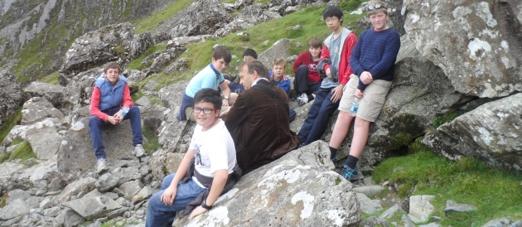
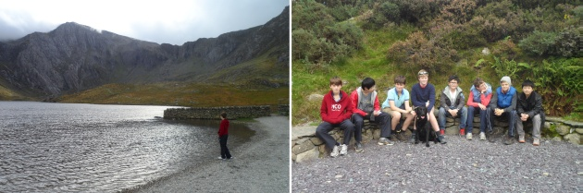
Extra-curricular education of the new Third Form reached new heights with a visit to 'Tally', our cottage in Snowdonia, on 5th/6th October. The effects of a steak dinner on the Saturday night followed by large cooked breakfast on the Sunday morning were countered by a glorious walk up to the Devil's Kitchen behind Tryfan on the Sunday afternoon.

Churchill's Kilted Benjy
Monday 14 October 2013
Last Monday, 14th October, Huntsman and Head of School Rory Fraser set himself the challenge of running a Benjy (1.5 miles) in under eight minutes wearing a kilt. He did it in 7.49 - and raised over £180 for the Sanata Restart Centre, which cares for and educates orphans and streetchildren from the town of Gilgil, Kenya. As a group, the Hunt have so far raised £850, which will pay for a child in Kenya to come off the streets and be housed, fed and educated at the Restart Centre for a year.

"I decided to run a Benjy in a kilt for two reasons: 1) I get really embarrassed asking people for money so I jolly well have to make it worth their while; 2) my family has quite strong African connections through my grandfather 'Rory Fraser' who died in his early 30s, so I thought he would have approved of my wearing the family tartan for a cause he would have undoubtedly supported! (The founder of the Restart Centre is also Scottish!)
The charity itself is completely fantastic. After hearing a talk about it, I was utterly inspired. I cannot stress enough how special I think it is. To use public school understatement, it is no mean feat running in a kilt, roughly the same drag as a bolshie five-year-old around your waist. But a large proportion of the donation relied on my getting under 8 minutes, so considering the severity of the situation, I ran like a nutcase..."

News of Annual OSH Runs and Dinner - Autumn 2013
Monday 14 October 2013
The Old Salopian Hunt will meet the RSSH and the Staff Runners for The Annual Run at 2.45pm on The Drum at The Schools, on Saturday 7th December. (Please note change of date). We welcome all, whether running, walking or spectating. If running, changing facilities can be in Houses or in The Swimming Pool building.
Afterwards, all are welcome in The Hunt Gym (Stott Pavillion) for Tea & Presentations. This is followed by The Committee Meeting in Kingsland House this year. At 7.30pm, there is The Annual OSH Dinner in The Peterson Room of Kingsland House. and if you would like to attend, please get in touch with Peter Birch to book at least 2 weeks before the event, as place numbers are limited. It never ceases to be an enjoyable day for all who attend.
Dinner price: £30 (includes drinks). Payment can be made in advance online here. Please book and pay by Sunday 24 November.
In addition, for the last three years, The OSH have been entering a team in The Thames Hare & Hounds Alumni Race, in Wimbledon. This year is the 60th anniversary and is to be held on Saturday 14th December, 2013 and is an excellent Cross Country event for all abilities. As long as you are an Old Boy or Girl of any age (18 - 98 ?), there is a running category for you to join in. If you are curious about the event or interested in running (or even spectating) do get in touch, preferably two weeks before, with David Thomas or Peter Birch (as above).

RSSBC: King's Chester Match
Monday 14 October 2013
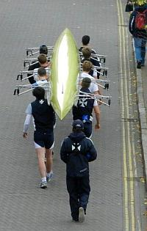
The Boat Club took seven senior and J16 crews to Chester to race against King’s Chester on the River Dee. The crews competed in two Head races – one over 4km and the second over 3km.
The crews were in eights, fours or quads. In the eights the King’s 1st boat was the quickest down the track, 5 seconds up on their respective Shrewsbury opposition. The King’s J16s also came in first against two fairly even Shrewsbury crews. In the girls’ quad, the boys’ quad and the four, the three Shrewsbury crews performed strongly against their opposition in that boat class.
It was a great opportunity to get crews out racing and many thanks go to King’s for their kind hospitality.
Meanwhile the J15s and J14s raced against King’s Chester at home. It is very early in the season for both groups, with the J15s learning to sweep after their year of sculling and the most of the J14s learning a completely new sport.
Results were favourable for our J15s, who had the fastest time of the day over the 1500 metre course. Our boys are racing in three matched eights at this time of the season – and certainly prospects are good with such a large year group. Congratulations to the fastest crew of F Simmons, H Marshall, R Hartwell, H Huntsman, C Cowan-Taylor, J Elliot, A King, H Lechmere and Cox R Assheton.
The 14s had a very useful afternoon. For most, it was their first competitive race. King’s did not send their J14s this time.
The next race for Shrewsbury will be on the 20th October when four crews will be racing in Boston (USA) at the Head of the Charles Regatta.

Football: w/ending 13th October 2013
Tuesday 15 October 2013
There were some outstanding football matches on Saturday, particularly at Millfield, where the 1st XI lost 3-1, however the 2nds (3-1) and 3rds (3-0) notched up memorable victories.
During the week, our impressive U16A XI were unfortunately knocked out of the ESFA Cup by neighbours Thomas Telford. The U15A's play King's Chester in their next cup match (ISFA Investec Cup 2nd Round) on Wednesday.
here were two excellent victories for the U16's and U14's vs Charlton School on Friday, and many more competitive fixtures against Market Drayton FC, Shrewsbury Up & Comers FC and Cheadle Hulme School on Saturday too.

Fencing: Resounding victory against Rugby
Tuesday 15 October 2013
Congratulations to the fencing squad who achieved a resounding victory against Rugby School on Saturday 12th October.
The Foil team of Marco Lee, Scott Reynolds and Justin Ko won 8-1; and Arthur Cheng, Charlie Godman and Jeff Pun won 9-0 in the Epée.

RSSH: Hunt runners smash the Marathon World Record!
Tuesday 15 October 2013
On Sunday 13th October 2013, the Hunt set out to beat the Marathon World Record while also raising funds for projects in Africa that they will visit during their tour during the Half-Term Exeat.
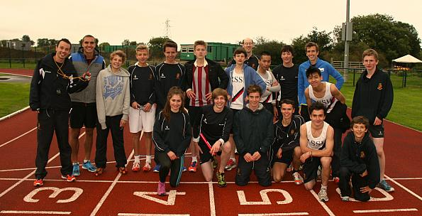
On Sunday, having earlier that day staged the annual RSSH Prep Schools’ Championships, the Hunt took a number of its members down to the London Road athletics track in search of a world record (albeit an unofficial one). Wilson Kipsang of Kenya had won the Berlin Marathon two weeks previously in an astonishing time of 2 hours, 3 minutes and 23 seconds – beating the previous record set two years ago by his compatriot Patrick Makau by 15 seconds.
As a mark of respect to these athletes – and in an effort to raise money for two charities the Hunt is supporting during its trip to Kenya and Ethiopia over Exeat (see elsewhere on the website for details) – we attempted to set our own record for the marathon by relay, hoping that by breaking the distance up into 105.5 sections of 400m sprints, we might have some hope of getting close to this incredible achievement. With sixteen of our fastest athletes, and four members of staff, we set about warming up on that rainy afternoon knowing that to break Kipsang’s time, we’d need to average less than 70.1 seconds per 400m, and that every one of us would need to do five laps or more. If you haven’t tried running 400m recently – and really, why haven’t you? – it’s worth giving it a go to put this sort of pace into context. We’d literally have to sprint as fast as we could on every lap if we were going to ‘keep up’ with world-record pace.
An over-confident start saw us take a notional ‘lead’ over Kipsang, and by the time everyone had done a lap we were streaking ahead – Kipsang was almost a minute behind by the time we’d hit 5K. This was due in part, however, to several of our number not really pacing themselves properly (including two rather over-excited members of staff) and on our second efforts, that blistering early pace proved hard to match. Split times dropped off dramatically and if that continued we’d soon find Kipsang beginning to gain on us again.
A bitter wind was blowing down the home straight that day and after 300m of all-out effort, it greeted us like a brick wall as we turned towards the change-over. Out of our athletics-season training, the technique for baton changeovers was also against us (often with comic results, especially when Sean Sawyer or Mark Huang were involved). Crucial time was lost as several relay hand-overs were completed in a style reminiscent of a Marx brothers film. Nevertheless, the fitness of this group of athletes was beginning to shine through, as gritty performances from all kept the split times from tumbling too far. Freddie Huxley-Fielding showed what great shape he’s in by running like an automaton, hitting splits of 66 seconds for each of his first four efforts (though a shocking inconsistency from him in his fifth and final effort saw him hit 65.9).
As we neared the half-way stage, a nervous glance at the watch showed us that we’d only just managed to beat the world record for the half marathon (set by Zersenay Tadese, since you asked, in 58:23) by about twenty seconds, but we were comfortably up on Wilson Kipsang, who theoretically trailed about four minutes behind us. That said, tiredness was definitely kicking in on our third and fourth laps and it was by no means certain that we could maintain a pace even closely resembling that set on our first laps.
Early on, there had been a queue of eager boys and girls hopping up and down wanting to be picked. After the hour mark, the queue had disappeared and Mr Haworth had to scout around for those willing to put themselves through another gruelling sprint. Mr Gunnell was among those wishing to give themselves ‘a bit more rest’ before stepping up again, though with his first two sprints well below 60 seconds, this was entirely understandable. Many of our most regular Hunt members were redoubtable however, and consistently bashed out 400m reps in times that kept us in with a very good shout of breaking two hours. Our regular Friday-afternoon intervals sessions on the river – though usually the subject of much bitter complaint at the time – were paying dividends at this stage.
With some Herculean efforts in the last few kilometres – and a fiercely competitive battle between Oscar Dickins and his Housemaster, Mr Middleton, for the lowest average split time – we approached the last few laps with time to spare. The nervous tension had gone, as we realised that not only was the world record likely to be beaten, but we were in all likelihood going to break it by a distance of a few minutes. Everyone wanted the glory of completing the final lap, but that honour went to Dr Oakley, who had been frantically entering split times every lap for nigh-on two hours. As he rounded the last bend and sped down the straight, the other athletes lined the track to congratulate him and each other on a job well done. Our time was 1:57:03.9.
More than anything, this exercise impressed on all of us the incredible speed that top marathon runners maintain for over two hours, and we left the track – though certainly with a great deal of satisfaction – feeling absolutely in awe of the athletic prowess of world-class marathoners like Wilson Kipsang. For those of us about to embark on our journey to Kenya and Ethiopia, it gave us a real insight into the speed these people can hold and the training and commitment required to achieve it, and whetted our appetite for the wonderful opportunity to meet such sporting heroes. Moreover, members of the Shrewsbury community have donated very generously to sponsor this event and we will be able to make donations to our two chosen charities for a total of around £1500.
Congratulations to all the members of the Hunt and athletics squads who participated in this event, and for the money they’ve managed to raise for such good causes. It was a truly great effort. And thanks to all those who have sponsored us!
IPH
The Hunt runners were raising funds for Running Across Borders, which supports running programmes for young people in Ethiopia.

Girls' hockey reports: Wrekin Invitation 7s, Bedstone College match, Shropshire County Tournament
Tuesday 15 October 2013
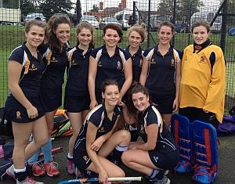
On Wednesday 2nd October Shrewsbury travelled a few miles up the M54 to Wrekin College for their annual Invitation 7s Tournament. Shrewsbury were in the 2nd half of the draw and with 5 teams to play, but only matches of 8 minutes one way, it was going to be fast and furious. Shrewsbury didn’t get off to a great start in their first game against last year's winners Denstone College. We were caught off guard from the outset and went 0-1 down after about 10 seconds. Shrewsbury fought hard for the rest of the game and produced a sound performance, only letting in one more goal to finish the match 0-2. Not a bad start against a strong Denstone team.
Our 2nd match was against Hereford Catherdral School and we were keen to put the Denstone match behind us. Shrewbury girls did just that and after having most of the play in the first 4 minutes got a deserved goal to go 1-0 in front. From here, we continued to play well and dominate the match, eventually putting in 2 more excellent goals from Alice Sykes-Waller and Charlie Perkins to win 3-0.
Match 3 was against Moreton Hall and despite Shrewsbury having the upper hand, we just couldn’t get the ball in the goal in the 8 minutes so the game finished 0-0.
Match 4 was aginast Shrewsbury High School who had looked dangerous in earlier matches, with a particularly strong centre forward. After 7 minutes the score was still 0-0 and was a good game of end to end hockey. The deadlock was finally broken by the High School and Shrewsbury lost 0-1.
Our final match was a frustrating game against Wolverhampton Grammar School. Shrewsbury had most of the play for the majority of the game, but Wolverhampton’s Keeper was excellent and managed to continually deny the pressure from our forwards. At the end of 8 minutes, the score was 0-0. Slightly disappointing results overall meant that Shrewsbury finished 4th, but some good performances in a fun format of the game to take ahead to our next game.

On Saturday 5th October, Shrewsbury hosted Bedstone College. This fixture has been more competitive over recent years and Shrewsbury was looking forward to pushing themselves. The game started at a fast pace and was pretty even for the first 5-10 minutes. After Shrewsbury had settled, they began to play some excellent hockey, keeping a good structure and working the ball into the opponents’ half more and more. After 12 minutes, Alice Sykes-Waller was rewarded for her hard work and Shrewsbury went 1-0 up. This gave us the confidence we needed and Shrewsbury went from strength to strength. Sykes-Waller positioned herself excellently, with some great moves down the right wing and Cecy Price supported well on the left. By half time Shrewsbury was 4-0 up. We continued to push forward in the 2nd half, with much of the play in Bedstone’s 25. Our midfield played some good balls into the D and the 2 forwards were able to convert them. Final score Shrewsbury 7 Bedstone 1 with 3 goals for Alice Sykes-Waller and 4 for Cecy Price

The County Tournament for Shropshire Girls Senior Hockey took place on Wednesday 9th October at Moreton Hall. There were 6 teams entered and games were to be 15 minutes one way – not a great format for Shrewsbury who have been slow to start this season and take time getting into their rhythm.
Our first game was against arguably the strongest side in the competition – Ellesmere College. Ellesmere had most of the play and the Shrewsbury defence were constantly tested. They held firm and kept Ellesmere out, resulting in a 0-0 draw in the first game. A good result.
Our 2nd match was against Bedstone and after our recent victory over them, we were confident. Shrewsbury played some excellent hockey and a total role reversal to the previous match. Unfortunately, just as Ellesmere were frustrated by their inability to score against us, we found ourselves unable to get the ball into the goal. Bedstone then went on the break and scored a fantastic goal against the run of play. Shrewsbury pushed on and got one back, but weren’t able to capitalise on their performance and the game finished 1-1. A frustrating result.
Our 3rd game was against Wrekin. Wrekin had had a bit of a shaky start to the tournament, but were improving every game and seemed to have saved their best for us. Wrekin pushed hard throughout the 15 minutes and despite some good work from Shrewsbury, they were too strong for us and Wrekin won 3-0.
Some good play over the afternoon, but work to do on the final execution.

Netball: Tough match in the Evening League
Tuesday 15 October 2013
On Monday 7th October, Shrewsbury played Dolly Mixtures in the evening league. They had recorded some good results in recent weeks and so this was going to be one of our tougher matches. At half time, Shrewsbury was 6-9 down and not in control of the game.
During the 2nd half, we began to play much better as a team, linking play well and moving the ball swiftly down the court. With 1 minute to go Shrewsbury was 1 goal down and were awarded a penalty pass or shot in the D which we converted to make it 14-14. The last 60 seconds were tense, with the ball travelling end to end, but shooters missing the target before Shrewsbury finally scored. Final score 15-14 Shrewsbury.
A great game for the whole team.

Lacrosse: North Schools Tournament, Queen Margaret's School, York
Wednesday 16 October 2013
Introduced this term, lacrosse is already proving to be a very popular option among the Sixth Form girls. We are fortunate in being able to draw on the expertise of England Under-21 player and Under-19 coach Hollie Harrington, who comes to the School twice a week to coach the girls. The North Schools Tournament last weekend was the first competitive lacrosse tournament that Shrewsbury has ever entered.
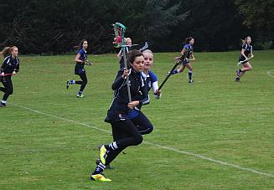
On Saturday 12th October we headed to Queen Margaret’s York for the North Schools Championships. This was going to be a big ask for Shrewsbury, competing at such a high level in their first tournament, but it was a great opportunity to develop our match play and knowledge of the full game. Shrewsbury were in the 2nd XII draw and would play five matches throughout the day. The aim was to improve with every game and learn to work as a team.
Our first match was against Uppingham. Due to traffic, the journey took just over four and a half hours, which meant the girls had to jump off the coach and straight into their first game. Without a warm-up, we were a little slow to get going, but one or two girls quickly found their feet and attacked the goal at pace. Shrewsbury went 1-0 up and continued to push forward. The game finished 3-3. A fantastic result in our first ever lacrosse match and something for the girls to build on throughout the tournament.
Our second game was against Queen Margaret’s 3rds. Unfortunately, after the euphoria of the first game, Shrewsbury just couldn’t get into the game and Queen Margaret’s went ahead with three goals in three minutes. From here, Queen Margaret’s found a steady rhythm that Shrewsbury just couldn’t keep up with and unfortunately we lost 10-1. Shrewsbury had a break between matches and therefore time to gather themselves ready for match 3 against Moreton Hall 3rds.
The game started with a fast pace and it was clear that Shrewsbury were more prepared for this one and working better as a team. The ball was passed more accurately and consistently and Shrewsbury were soon rewarded with a goal. Moreton came back hard and equalised soon after, but Shrewsbury stepped up a gear to make it 3-1 at half time. Both teams played some excellent lacrosse in the second half and with two minutes to go, it was 4-4. Our final chance came from Alice Sykes-Waller running down the right wing, passing in field to Immy Hill who took on three players and scored. 5-4 Shrewsbury. A great game and much deserved result.
Match 4 was against Queen Margaret’s 2nds, and after our game against their 3rds, Shrewsbury were apprehensive, but had a new determination from their win over Moreton. Just as we finished the last game on a high, Shrewsbury started well and went 1-0 up. Abby Attenborough and Izzie Croft kept the pressure on through the midfield and Natalie Seager made some excellent saves to keep Shrewsbury in the game. 2-2 at half time. In the 2nd half , Hattie Warner made some fantastic runs forward and by the final whistle, Shrewsbury had won their second game of the tournament; 4-3 the final result.
Our final game was against Moreton 2nds. This was always going to be a tough match, but Shrewsbury were in good shape from their previous two wins and were playing much better as a team. Moreton went ahead early on and proved to be too strong for Shrewsbury overall. We played some good balls into the D, but good goalkeeping kept us out for the majority of the game. Final score, 1-8 Moreton.
Overall, Shrewsbury had 2 wins, 1 draw and 2 losses. A great result for our first entry in the North Schools Tournament and something to build on over the next few months.
NJB

The Annual Prep Schools' Cross-Country Championships
Thursday 17 October 2013
Now in its third year, the Prep Schools' Cross-Country Championships held here on the School Site has grown to become a major fixture on the prep schools' circuit. This year we welcomed more than 200 boys and girls from 16 prep schools from around the country for a tremendous afternoon of racing at both under-11 and under-13 level.
Despite the wet and dreary weather (ideal for cross-country!) we were delighted that huge numbers of parents and supporters came to spectate. The new start and finish on Top Common provided excellent vantage of the early and late stages of the course, whilst the traditional route down to the river provided the usual tough challenges of gritty hill climbs and fast bursts of speed along the river path.
The first race of the day saw the U11s take to the course, which was a shorter 3km route. Over a hundred competitors set off at a frenetic pace, chasing the 'hare', Huntsman Rory Fraser (Ch). There was little between them as they passed down through the Masters' Garden and down to the Boat House, but as they returned for the final 400m finish back on Top Common, a fierce battle looked to be on for the medals, and indeed, at the finish race winner Daniel Bufton from St Richard's was a mere eight seconds ahead of Prestfelde's William Lewin, with the pair finishing in 11.52 and 12.00 respectively. The final medal position was equally close with Caleb Adams of Old Hall School taking the bronze in 12.30, four seconds ahead of Alfie Biggs of Prestfelde and Reuben Crombie of Old Hall School, both on 12.34.
However, in amongst the leading boys emerged the first girl home, with Ellesmere's Esme Hughes coming home in 12.12, not only the winner of the girl's race, but in fact the third athlete home out of girls and boys. She demonstrated last year her prowess at the championships, and this year has cemented her reputation as an athlete of prodigious talent and potential. Second girl home was Terra Nova's Francesca Harris in 12.50, with a trio of St Richard's girls fighting for the bronze, with Mary Hayton Lee taking the honours with 13.27. The team trophies were won by Prestfelde in the boys' event, and St Richard's in the girls' event, with both schools exerting clear dominance at this level.
U11 Team Results: Boys (4 to count)
1st Prestfelde - 26 points
2nd Packwood Haugh - 52 points
3rd Maidwell Hall - 59 points
U11 Team Results: Girls (4 to count)
1st St Richard's 19 points
2nd Maidwell Hall 50 points
3rd Terra Nova 69 points
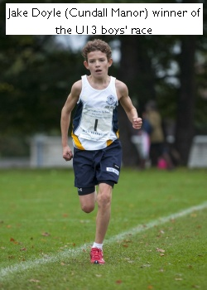
The U13 event saw a slightly smaller field of just under 80 athletes, but the race was certainly no less competitive. With last year's dominant school Maidwell Hall having missed out on the team trophies at U11 level (albeit with a very young boys side who will surely be difficult to beat next year), they were keen to stamp their mark and return with some silverware having won three out of the four trophies last year!
At the front of the pack, two Maidwell athletes (George Henderson and Monty Fenwicke-Clennell) made quick work of establishing crucial points for the team, though from the very outset they could not match the pace of Cundall Manor's Jake Doyle, who had cemented a 20m lead by Masters' Garden. It was a lead that he would not yield, and indeed, by the close of the race, Jake came home over a minute quicker than Henderson in 2nd.
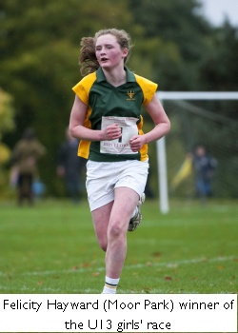
Jake's time of 14.59 for the 4.2km course is exceptionally quick given the difficulty of the course and the conditions, though of course, over the past three years we have come to expect this of a young man who is one of the most talented prep school athletes in the country. He makes history in having won the individual title three years in a row - U11 winner in 2011; U13 winner in 2012; and U13 winner in 2013. Henderson and Fenwicke-Clennell (16.05 and 16.11) are extremely strong athletes in their own right, and well deserved their individual medals. Crucially, their performance - combined with Timothy MacNaughton's 6th place and Alex Saunders's 14th place - ensured that Maidwell Hall retained their U13 trophy with 25 points, 23 points ahead of second placed Prestfelde, with Packwood taking the team bronze with 73 points.
The U13 girls’ race was a closer affair, with Felicity Hayward of Moor Park taking the early lead and attempting to run the race from the front. However, she was pursued relentlessly by Jessica Humphreys from Shrewsbury
High Prep, and by the end of the race, the gap had narrowed to just two seconds! Hayward managed to hold on - just - and provided us with one of the most exciting finishing battles that we have seen over the past three years to win in 17.34. Birchfield's Lillian Wilcox had an equally tight finish with Terra Nova's Eve Baker-Wilbraham, with just one second separating them at 18.13 and 18.14 respectively. The team event was won comfortably by Maidwell Hall who retained the trophy with 39 points (good 'packing' with 7th, 8th, 11th and 13th for their 'counters'). St Hugh's were delighted to return home with some medals, taking team silver, with St Richard's concluding a very successful afternoon of racing for them with the team bronze.

U13 Team results: Boys (4 to count)
1st Maidwell Hall 25 points
2nd Prestfelde 48 points
3rd Packwood Haugh 73 points

U13 Team results - Girls (4 to count)
1st Maidwell Hall 39 points
2nd St Hugh's 57 points
3rd St Richard's 65 points

As ever, the event saw some gritty performances from all athletes, and it was terrific to see such enthusiasm and determination. In the past three years we have seen a number of the top performers join Shrewsbury School and its running club the Hunt, and this can only be good news for Shrewsbury running in the future! Well done to all the competitors, and we look forward to next year's event.
PJM

Former Horse of the Year Show champion in bid to defend title
Thursday 17 October 2013
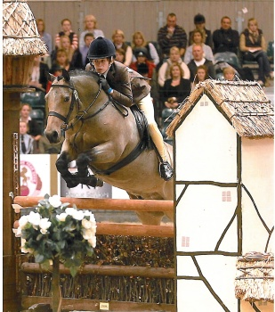
2011 winner of the 13 WHP U14 section of the Horse of Year Show George Holder (Ch, IV) was away last weekend in a bid to regain his title. This challenging event requires the versatile rider to jump a course of 12 rustic fences, ‘show’ the horse on the flat and perform various procedures to achieve a ‘confirmation’ by the judge. Twenty-five contestants had made it through the qualifying rounds to be at the finals, held in the Birmingham NEC. With limited opportunity for practice in term time, George was delighted with his third place, riding his beloved dun ‘Rossdale Sandpiper’, stable name Dougal.
"I was really happy with third place," says George, a former Aysgarthian who lives near Ullswater in the Lake District. ‘It was a great way to end three years in this section. I am already looking forward to the higher class next year, with hopefully a little more racing.’
RTH

Three days at 'the Shewsy'
Thursday 17 October 2013
Last week, a group of Lower Sixth Sixth Formers took part in one of several Social Studies Courses organised each year at Shrewsbury House - known to generations of Salopians as 'the Shewsy' - a youth and community centre in Everton, Liverpool, which was set up by masters from Shrewsbury School in 1903. Joe Lafferty (PH LVI) reports back.
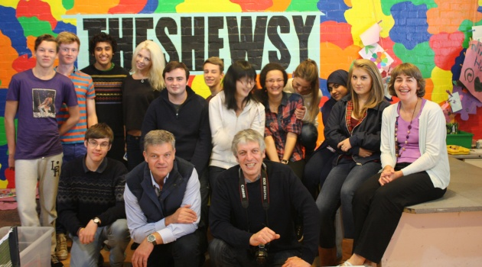
The Headmaster, Warden Henry Corbett, Lesley Drew and members of the Lower Sixth at the Shewsy
(The author of this article, Joe Lafferty, is fifth from the left at the back)
At 3 o'clock on Tuesday afternoon I, along with my 11 compatriots and two teachers, assembled at the minibuses at the back of KH for one of many trips the School runs to the Shewsy. The Shewsy is a youth club in Liverpool - Everton to be specific - which was set up in 1903 by masters at Shrewsbury School. Every five years – in my case in the Fourth form – we all walk an incredible length on the ‘Shewsy Sponsored Walk’ - about 25 miles in total and in 2011 we raised almost £50,000. One of the many things that I learnt on this trip was that 53% of children in Everton live in poverty. In fact, in Liverpool, it trails only to another area called Princes Park at 58%.
When we arrived at the Shewsy, we were greeted by the local minister and warden of the club, Henry Corbett. He gave us a brief introduction to the history of the club, its activities in the community and an overview of the area as a whole – both past and present. We then threw ourselves into Kids’ Club. I have two little sisters, a three-year-old and a five-year-old, so I had a vague idea of what to expect. I went straight to the gym where I joined in a game of football with some seven-year-olds who were stratospherically better than me. There was a brief interlude when about eight or nine small girls (I couldn’t quite count, partly because of the mayhem but also due to my hysterical laughing) were chasing a fellow Salopian around the gym, tickling her with a maniac determination. Then came dinner cooked by the lovely and delightful mother/daughter team of Chrissy and Teresa. It was shepherd's pie and was quite welcome, considering I had two more hours of football coming up in Senior Club. It was at this point I met Dave and John, two of the youth workers at the Shewsy, John being a product of the Shewsy himself.
I woke up at 7:30 the next morning and jostled for position in front of the two showers with the other members of our group. The girls cooked breakfast on the condition that we wash up. At 9:30 we went on a minibus tour of the area led by Henry. We stopped off at the Hillsborough tragedy memorial at Anfield and then went into Liverpool for a spot of sightseeing. Due to my family links to shipping in Liverpool, I set upon the Maritime Museum eagerly. My great-great-grandfather T.W Hankinson was the Chief Officer of the Carpathia, which was the first ship to the scene of the Titanic and they managed to save 795 lives. This was followed by a brief visit to the Tate and then off to Liverpool One for lunch. We got back at 3:20 and went straight into Kids’ Club. I played more football and met Alex and Frank, two of the many volunteers at the Shewsy from the local area. We had curry for dinner and once again joined Senior Club. I gave my legs a rest and played snooker and darts and listened to the wonderful music of Joey Symes and his band: http://www.joesymes.co.uk/ We all had a big game of football before bed, which everyone enjoyed as it was filled with many funny moments and tired everyone out.
The next morning I helped with breakfast and soon we had a meeting with Jane Corbett, the local councillor for Everton and Henry's wife. One thing that has stuck with me from her talk was a story about a boy called Jack. Jack is five years old. His mother worked in two cleaning jobs to try to provide basic necessities for him. However, once she walked into his room and saw him peeling wallpaper off the wall to eat. Cue shocked and stunned silence and the statement from Huda, who is from Bahrain: "I didn't associate Britain with poverty". None of us did. We hear stories on the news about people in need. But then we hear ten times as many about benefits cheats and fraudsters. In reality, they make up a tiny minority of people who claim welfare. Much of it is unreported, as the truth about the situations people are in across the country, faced with cuts and the ‘bedroom tax’, and re-testing for disability benefits “is just too complicated to explain”, as one journalist told Jane. She thought they should try harder!
We were also told about the regeneration of Liverpool under Old Salopian Michael Heseltine and about how the city struggled under militant leadership during the 1980s.The Headmaster came to meet us in the last ten minutes of the meeting and spent the rest of the day with us. We then went to speak with Dave and John about the importance of community and how we would spend a government budget. I had a brief debate with the Headmaster over quantative easing. Later, we participated in a Geography lesson, a subject in which I am hilariously inept, about the differences in healthcare between Chicago and Kinshasa in the Congo. I thoroughly enjoyed the lesson and thought the newly-opened school, also in Everton, was marvellous. Having taken time to look at the amazing art on display, we headed back to the Shewsy. We took part in the final Junior Club of trip and said our goodbyes to all the kids on their way home.
I learnt a huge amount, not just about the Shewsy but the state of Britain itself, and am so immensely grateful for the opportunity to go there. As I type this on my iPad after dinner, I cannot help but think of Jack and the thousands like him. It has also helped me realise how incredibly lucky I have been in my life and that is a realisation that will be with me forever. I would wholly endorse this trip to anyone who either wants to learn about those less fortunate than the pupils of Shrewsbury.
Joe Lafferty (PH LVI)
For more information about the Shewsy, please visit www.shrewsburyhouse.org.uk

Prospective pupils enjoy a 'Mountains and Meadows' taster event
Thursday 17 October 2013
We were delighted to welcome 118 prospective 2014 Third Form entrants and their families to the School last Sunday for a chance to meet a wide range of staff and enjoy a series of fun and, we hope, informative activities and presentations giving a taster of life at Shrewsbury.

Over 300 excited, curious and no doubt in many cases slightly nervous boys, girls and parents gathered at Shrewsbury School last Sunday for the first of what is intended to be an annual ‘taster’ event for pupils about to join the School, or interested in joining. The children, efficiently colour coded and divided into groups (Everest, Ben Nevis, Kilimanjaro, Fuji, Snowdon) and waving happily to their parents, were whisked off to a series of fun and interactive sessions designed to introduce them to some of the academic aspects of Salopian life. These ranged from exploring mountains on the moon in Physics to completing expedition training in Biology, via food tasting from around the world in Modern Languages, a ‘Do you have what it takes to climb Everest?’ session in Geography and a ‘Who Wants To Be A Millionaire?’ style quiz on mountains in the Bible from Philosophy & Theology (RS).

Their offspring thus happily engaged, parents were treated to a series of talks and presentations in the Ashton Theatre, the undoubted highlight being an unscripted and unrehearsed panel of the most recent intake of Third Formers who spoke enthusiastically, sometimes disarmingly honestly, always reassuringly, about their first weeks at Shrewsbury. Talks and presentations were interspersed with ‘a capella’ music provided by Churchill’s Hall and by Connie Osborne of Mary Sidney Hall on her ukulele. Parents and children were then reunited for a grand
‘Mountains & Meadows’ themed tea party in the Alington Hall, friendships already beginning to form amongst the boys and girls. We were delighted to be able to meet so many parents and prospective Salopians who braved the wild weather to be at the event and look forward to welcoming them again soon.
RTH
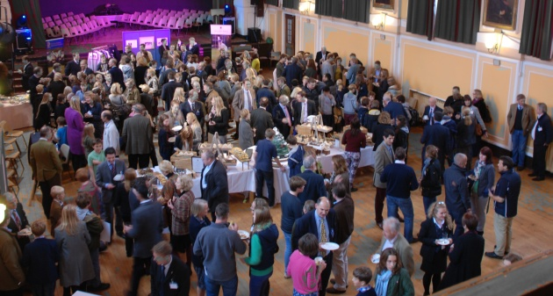

Field Day – Thursday 10th October 2013
Thursday 17 October 2013
A sunny morning greeted those pupils setting out for the great outdoors for this latest Field Day. On Field Days, held termly, there are no formal lessons and pupils from Third to Lower Sixth forms undertake a whole day on their chosen activity. We had a very diverse range of trips this year: the mountain bikers set off for South Shropshire; the RYA Yachtmaster group visited Barmouth Lifeboat Station; the CCF had an overnight exercise; a group visited the Shewsy; Art Historians went to London; canoe groups paddled down the River Severn; Community Drama visited an old people’s home; gliders glided; Young Enterpise companies continued to set up their businesses, and so on. Overall there were some 35 different group activities. The sample of reports below give a flavour of what went on. Some are written by pupils and some by staff.
RYA visit to Barmouth Lifeboat Station
Long as the journey may have been, it was definitely worth it. After passing numerous Welsh signs that made us seem illiterate, the first wisps of sea were seen from a distance. As the tide retreated, banks of rippling sand advanced closer to the winding road that led us into the charming little port of Barmouth. Albeit cold, we were blessed with plenty of sunshine that reflected off the pallid sea where boats dotted the water.
At Barmouth, we parked the minibus next to the RNLI station, right below the rocky hills and in front of the great stretch of dove grey beach. Unlike the picturesque port, the interior of the station, to me did not resemble the charming little town of Barmouth; standing over us at the entrance of the station was the Moira Barrie - a 38-feet long Mersey-class lifeboat. Next to it hung a sign that kept count of how many people have been saved by the Barmouth station and a number of impressive panels recording previous coxwains and lifeboats for the last 180 years.
We were extremely grateful to have three members of the station, including the station mechanic, to take us around the station and the changing rooms and to show us the instruments on board the lifeboats. There was a stunning amount of instruments on board the lifeboat, not to mention the sheer amount of food carried for the crew as well (variety of food is definitely not as good as Kingsland Hall though!). We also had a chance to try on some of the lifejackets, tour around the crew room and climb into the tractor that tows the Moira Barrie.
The visit to Barmouth (and the Marches!) was extremely memorable and definitely one of the best ways to wind this half term down! On behalf of all the other Yachtsmaster Candidates who came on this trip, I would like to thank the crew at Barmouth RNLI for showing us around, and Mr Lapage for arranging this trip, stop on numerous occasions to refill the coolant of the minibus and taking us to a chippy!
Dan Lo (SH LVI)
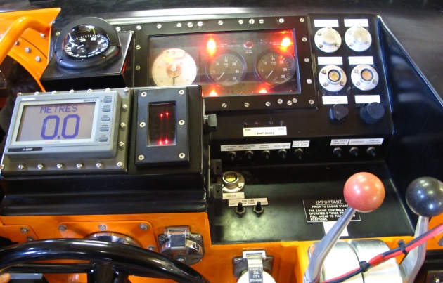
Inside the Barmouth lifeboat
Building Society
Sun shone brightly on the Building Society’s progress through Worcestershire and South Staffordshire. The morning was devoted to a visit to the ruins of Great Witley Court, one of the nation’s largest county houses, which became derelict after a fire in 1937. English Heritage has preserved its skeleton, allowing architectural students an excellent view of the anatomy of a great country house and has fully restored the gardens with their magnificent stone fountains, capable of sending pillars of water a hundred feet into the air. We also visited Great Witley Church, lavishly decorated in the late Baroque manner including ceiling paintings by Antonio Belluci.
In the afternoon, the Builders were indebted to the generosity of Lord Cobham in touring Hagley Hall, a fine example of English Palladian architecture, featuring some of the finest plasterwork to be found in an English private house.
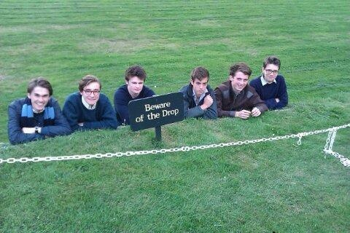
The Builders man the ‘ha-ha’ at Hagley Hall
As a ‘bonne-bouche’ with which to end the day, the Builders were allowed to look round the cellars of the late 17th Century building from which the wine-merchants, Nickolls and Perks, has conducted its business right through until the present day.
MASW

Combined Cadet Force
We held a voluntary night exercise – where a good number of new ‘recruits’ and Fifth Form Leadership Cadre members took part in Exercise Terror Torment designed to test leadership of our Fifth Form in various scenarios, based on a the narcotics trade (run by senior cadets acting as an Eastern European narcotics ring.) Patrols encountered marauding cows but did eventually locate the ‘enemy’ and some suspect items were captured (KH flour wrapped up in plastic.) The friendly forces had partial success, although the enemy escaped.
Sgt Oli Pattison-Appleton (Ch UVI)

Some marine cadets took part in the night exercise and met up with the RM Pringle team later in the morning. The morning was spent preparing for a demonstration to be given to younger cadets illustrating the skills of the RM section. This comprised of several section attacks culminating in an assault on an enemy position where the ‘baddies’ were neutralised. All in all a good day, great fun and I think the younger cadets were very impressed.
Sgt H Young (SH UVI)
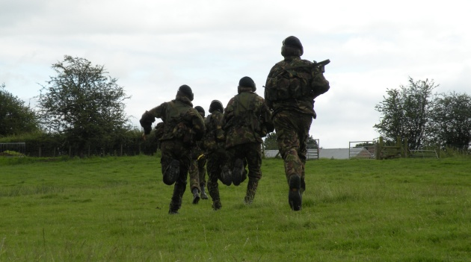
CCF cadets arranging a casualty evacuation
Third Form First Aid
Our Third Form boys were given a three-hour intensive first aid course by specialist trainers from St John's Ambulance. First covering essential ground with "DRABC" they gave mouth to mouth to "resusci annie" dolls, put each other in the recovery position, learned the symptoms of a heart attack and bandaged horrid gory wounds on each other's arm and legs. The trainers kept the boys on their toes with sudden, dramatic, role-played accidents, lending urgency and a real sense of how crucial these new skills may one day turn out to be.
TSM
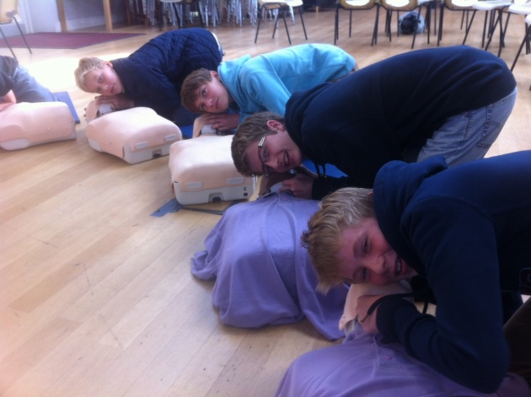
Third Form First Aid pupils listening for a heartbeat'
Golf
A great day was had by all (10 students 3 staff) on the beautifully tree-lined course of Henlle Park near Oswestry.
After a start of bacon butties and hot chocolate, we tee-ed off. Ben Jones frightened the life out of the groundsman by hitting his tractor, and Oliver Murray immediately hit so far out of bounds that he wasn’t seen again until dinner time in the club-house! However, play settled down after this shaky start, and eventually Alex Haspel came out on top with an impressive round of just 6 over par. James Walker won the longest drive competition and George Birt was closest to the tee on the short 15th. Dr Foulger won the Barnes Wallace prize for making his ball bounce across the lake at the 9th!

Thanks go to the Secretary and members of Henlle Park for making us feel so welcome, and to Mr Schofield and Mr Joyce who accompanied us on the trip and showed us some excellent golf in the process.
TRF
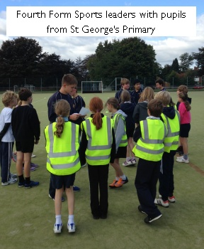
Canoeing
We had a lovely scenic canoe down the River Severn. After we unloaded the canoes from the van we started the trip from Montford Bridge and paddled downstream for about two hours. We stopped for lunch to eat a packed meal provided by the School (yum!) and rested for about half an hour. The weather was really quite fair and not as cold as I thought. All in all tiring, but a great trip.
Ed Paul (Rb LVI)

Sports Leaders
This group of Fourth Formers have been working on developing their skills at organising and facilitating sports events. Field Day gave them a chance to arrange a sports event for the pupils from nearby St George’s Primary School. The photo on the right shows this in action.

Giles Bell’s ‘Team of the Week’
Thursday 17 October 2013
In previous weeks this term, Giles Bell has turned his spotlight and his wit on a number of the School's football teams - and on the Chapel Choir. For this week's 'Team of the Week' feature, he went to meet the girls' hockey team.
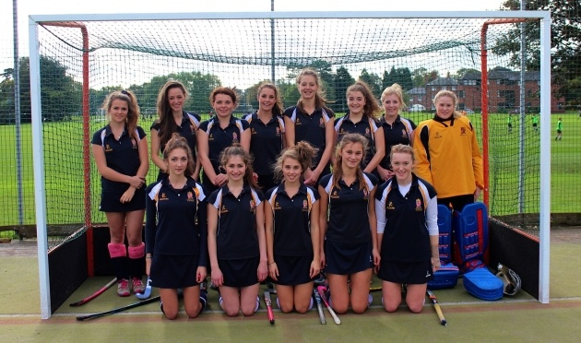
This week I have been invited to talk to the School’s premier girls’ hockey team. So far they have had a good season and the new signings are settling in well. This year, new coach Katie Collins (KC) has been added to the existing coaching team of Chris Cook and Nicola Bradburne. I visited the squad at training before their big local derby with local rivals and county champions Moreton Hall. KC and her 'sunshine band' were in sparkling form and although they knew they were in for a tough time against the Moreton Marvels, confidence and fortitude were not in short supply.
They are a deeply philosophical and rational bunch of young women and that quickly became apparent in our conversation. I asked well respected captain, strong, cool and calm defender Eliza Wood how she perceived the team. “We are like the Trinity, everywhere but indivisible,” she replied. Senior pro and jovial but focused midfielder Gabby Byrne was quick to add, “As soon as that whistle blows we are united as one.” Gabby continued to tell me that she regarded the team in a familial sense. “We are like a family,” she said. I asked her to expand on this statement and after a lengthy period of reflection (during which the squad could probably have worked on their short corner routines), she replied: “We are like sisters.” When asked how they felt about the impending dual with Moreton, Charlie Perkins, the team’s great transitional midfielder, commented: “We are sick.” (I think she meant that they were good enough to defeat Moreton rather than they were sick of my questions or sick with fear.)
I asked the coaching team what I could expect to see on the pitch in the match. ‘The’ Cook is keen to stick to his principles of exciting, well presented, spicy hockey with a sprinkling of goals and a garnish of goalmouth action. KC was concerned that the forecast of rain might affect the ‘sunshine band’. KC was right to be concerned, as the weather was not good and as the clouds rolled in, the crowd began looking for shelter. Women’s hockey has been attracting bigger crowds of late and it was good to see Miss Woo, Miss Rule and Miss Peak shoulder to shoulder in the West Stand. At the start of the match the usually sanguine Cook was in particularly good form, having just won the Shrewsbury bake off. He was confident that his diamond formations would help the girls ‘do the trick’ - after all, as he told me, “Diamonds are a girl’s best friend”.
I had brought four-legged hockey expert Ted with me to watch, as he can usually sniff out a goal. I could tell he was enjoying the game from the pressure he was exerting on his lead. The goals went in, but in the wrong end and although the Shrewsbury team tried their best and peppered the Moreton goal, they could find no way past the goalkeeper. Sadly she continued throughout the match to thwart the usually razor-sharp strike force of Cecy Price, Alice Sykes-Waller and Antonia Schueler, and the score eventually reached 5-0 to Moreton.
After the game Mr Cook told me: “We were well roasted today. At least we kept our composure and emotions did not boil over. Perhaps we were a little under done in terms of our preparation. That can be a recipe for disaster. There have been a few issues simmering under the surface but we will bounce back with a tasty performance next game. I am drawing up an intense training menu for half term.” Miss Collins was similarly upbeat. "The end result did not reflect the game’s play. However it has highlighted many areas for us to focus on after half term. With the team unity we have, I am sure we will come back fighting and aim to finish this season on a high."
Despite this particular result, there is a great spirit in this team. The squad consists of Eliza Wood, Charlotte Harris, Charlotte Perkins, Alice Sykes Waller, Gabby Byrne, Edie Whittingham, Millie Dean, Esmé O’Keeffe, Mary Parrott, Cecy Price, Antonia Schueler, Jo Cull, Tory Mobley, Phoebe Barboza, Nicola Spruyt, Raphie Major and Daisy Raichura.
GJFB
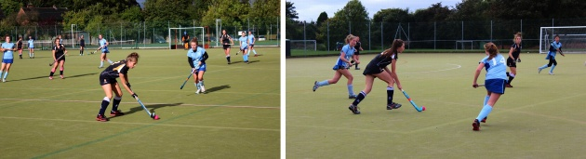

Old Salopian City Drinks on Thursday 28 November: The Travellers Club, Pall Mall
Monday 21 October 2013
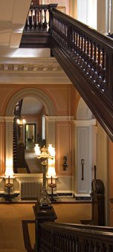
Old Salopian City drinks will this year be at the Travellers Club in Pall Mall.
The original concept of The Travellers Club by Lord Castlereagh and others dates from the return of peace in Europe following the Napoleonic Wars. They envisaged a club where gentlemen who travelled abroad might meet and offer hospitality to distinguished foreign visitors and diplomats posted in London who might enjoy the privilege of using the Club. It was founded in 1819 and moved to its present purpose-built clubhouse, designed by Charles Barry, in 1832. The intention of its founders was to provide a meeting place for gentlemen who had travelled abroad, their foreign visitors and diplomats posted in London who might enjoy the privilege of using the Club.
Throughout the Club's existence distinguished members of the Diplomatic Service, the Home Civil Service, and the Armed Forces have come to the Travellers Club, while other professions have increasingly been added to the membership.
Event Details:
Time: 6pm - 9pm
Open to: Any member of the Salopian Community and their wife/partner
Address:
The Travellers Club
106 Pall Mall
London SW1Y 5EP
United Kingdom
Telephone: 07079 308 688
Etiquette
Although The Travellers is a gentlemen’s club, ladies are welcome as guests throughout the Clubhouse other than in the Smoking Room and Cocktail Bar, which are reserved to gentlemen and their male guests.
Smoking is not permitted anywhere in the building. Mobile phones should be turned off when entering the Clubhouse, and may only be used in the phone booth in the lift lobby or in the front hall by reception. Similarly, business papers should not to be displayed in the public rooms; those wishing to conduct business may do so in the main hall.
Dress Code
The Travellers has a formal dress code (jacket and tie, or national dress – no trainers or denim) throughout the building, Ladies are expected to dress to a similar standard.
Booking
Please email the Old Salopian office: oldsalopian@shrewsbury.org.uk

Old Salopian Birmingham City Drinks on Thursday 5 December
Tuesday 22 October 2013
All Birmingham-based Old Salopians and Salopian parents are cordially invited to join the Chairman and Committee of the Old Salopian Birmingham and West Midlands Branch, Richard Woodgate (Rt 1954-59) for drinks and ‘nibbles’ at Edmunds Bar, a popular venue in Central Birmingham on Thursday 5 December, from 6pm. Please note that, as usual, wives and partners are also very welcome and the first drink is free!*
The School Guest of Honour for the evening is Will Hughes (G 1988-90), current Housemaster of Ridgemount.
Dress code: smart casual
Richard has booked a table afterwards for anyone who would like to join him and the Committee at the stylish new restaurant, Carlo Fumo (pictured, left) for an Italian meal. Guests will be able to choose and pay for their meal on the night.
Booking: (for the drinks and/or the meal) email the Old Salopian office: oldsalopian@shrewsbury.org.uk

Event Details
Edmunds Bar
106-110 Edmund Street, Birmingham B3 2ES 0121 200 2423 info@edmundsbar.co.uk

Carlo Fumo
Waterloo Street Birmingham B2 5PG 0121 643 8979 fumo@sancarlo.co.uk
(pictured, right)

*event sponsored by the Salopian Club

An invitation to this year's Shrewsbury Christmas Drinks on Friday 6 December
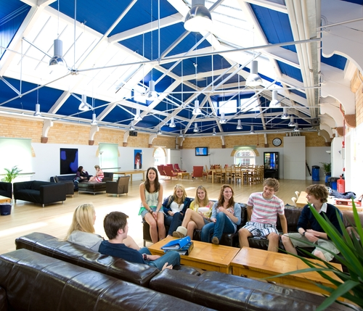
Thursday 24 October 2013
All members of the Salopian Community within reach of Shrewsbury (Old Salopians, current and former staff members and past and current parents) are warmly invited to the Salopian Club's informal Christmas drinks party on Friday 6 December at 5.30pm.
A seasonal chance to catch up with old friends and acquaintances and timed to allow those people attending the carol service* at 7.30pm in the Chapel to call in for a drink and a 'bite' beforehand.
Venue: The Quod (6th Form Common Room)
Time: 5.30-7.30
Drinks and 'nibbles'
Dress code: smart casual
RSVP: to oldsalopian@shrewsbury.org.uk or 01743 280 892 or 4 by 28 November, please
Free event
*Attendance at the School Carol Services is by invitation only. The Salopian Club can sometimes obtain a small number of tickets. Please contact us after mid-November if you require a ticket and we will do our best!

Old Salopian Weekend 2013 - a selection of photos are now available to browse
Thursday 24 October 2013
Excellent weather helped this year's Old Salopian weekend get off to an excellent start with a Golf tournament at Worfield on Friday 20, followed by the Gathering itself on Saturday, 21 September.
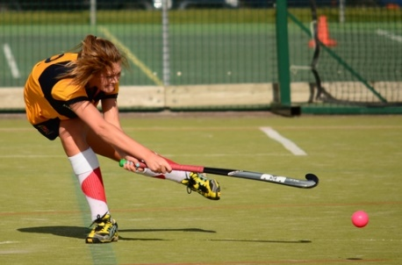
The lunch and sports activities attracted almost 200 guests including former staff and many Old Salopians of all ages. Football, netball, hockey and fives were represented and the day was only marred by the absence of Club President, Nick Bevan (O 1955-60) and former staff (1972-88), unfortunately prevented by ill health from attending. Fortunately, Past President, Hugh Ramsbotham, a close friend of the Bevan family and a direct contemporary of Nick’s, was able to step in to preside over the day and also to be Acting President until Nick is well enough to resume his duties.
Clicking on this photo, above, will take you to a selection of photos taken during the weekend. Many thanks to the various contributors to this collection.
Towards the end of the afternoon, former master and renowned Fives player, Robin Moulsdale (I 1942-46), former master (1951 - 81) unveiled the attractive new Fives Courts boards which list all the Fives champions and finalists from the 1920s to present.
Two boat crew reunions and rows-past were also held during the weekend. The 1978 crew enjoyed a reunion dinner in the refurbished boathouse club room on Friday evening, while the 1988 crew, who had been coached by Nick Bevan, were reunited at the Old Salopian lunch.
The third annual Alex Wilson Memorial match was held on Sunday 22 and was won by the Old Salopian team, 2-1. Afterwards, Alex’s brother, Henry, gave a short update on fundraising efforts for the Alex Wilson Scholarship.
A full report of the weekend will appear in the next edition of 'The Salopian' magazine, due to be distributed in December.

OSGS: Ashridge Golf Club on Friday 1st November - Last Chance to Book!
Tuesday 29 October 2013
NEWSFLASH
Last chance to book for Ashridge Golf Club on Friday 1st November 2013. Please book by Wednesday 30 October, by 5pm, latest.
Address: Little Gaddesden, Berkhamsted HP4 1LY, Telephone: 01442 842244
07:45 Coffee & Bacon Rolls in the Mixed Lounge
08:30 Fourballs Stableford off 3/4 handicap
13:45 Club Carvery lunch & prize giving
Limited to 24 players—first come first served.
Cost: £75: (under 35s: £50) Members: £25

